OudhTrade
Admin UX Design Brief — Onboarding
Designer brief — the admin (staff) screens used in user onboarding
Document details
Company | MRIDA INFRA AND PLANTATIONS LLP
Product | OudhTrade — oudhtrade.com
Document | Admin UX Design Brief — Onboarding
Scope | 25 staff screens for onboarding (queues, settings editors, lists, look-up) in the admin console; content from M01, M02 and M03
Readers | UX/UI designer, frontend developers, product owner
Related documents | UX-UI Foundation · M01-6 Section 12 · M02-6 Section 20 · M03-6 Section 16 · Admin Screens Tracker (Excel)
Owner | Product owner
Decision owner | T. Satish Reddy, CEO & Founder
Status | Draft for review — 26 September 2026
Classification | Confidential — for partners and the OudhTrade team

Contents
1. Purpose and How to Use This Brief 3
1.1 How to work with it 3
1.2 Where each fact lives 3
2. Staff Users and What They See 3
2.1 Role and screen matrix 4
3. Admin Console Shell 6
3.1 Layout 6
3.2 Menu 6
3.3 Keyboard and accessibility 7
4. Shared Patterns (Design Once) 7
4.1 P1 Queue + case review 8
4.2 P2 Settings editor 9
4.3 P3 List management 10
4.4 P4 Look-up 11
4.5 Common states for all screens 12
5. Screen Inventory 13
6. Screen Pages 15
AD-01 A — Verification review 15
AD-02 Video-call ID checks 17
AD-03 Sanctions batch and match review 19
AD-04 B — Role change decision 21
AD-05 C — Farm visit review 23
AD-06 Recovery and number-reclaim review 25
AD-07 Staff-awarded badge applications 27
AD-08 Lab accreditation review 29
AD-09 Partner programme review 31
AD-10 E1 — Document checklists 33
AD-11 E2 — Business ID rules per country 35
AD-12 E3 — Rejection reasons 37
AD-13 E4 — Setup card items per role 39
AD-14 E5 — Role change paths and capability bands 41
AD-15 E6 — Badge types 43
AD-16 Country table 45
AD-17 Throw-away email domain list 47
AD-18 Changes / approvals 49
AD-19 Invitations admin 51
AD-20 Field agents 53
AD-21 Delegations overview 55
AD-22 Farm-visit queue by district 57
AD-23 Agent and FPO quality re-checks 59
AD-24 Account lookup 61
AD-25 Support profile and case view 63
7. Key Journeys 65
7.1 J1 Business verification case 65
7.2 J2 FPO onboarding and member farmers 65
7.3 J3 Field-agent farmer onboarding 66
7.4 J4 Buyer asks to sell 66
7.5 J5 Settings change 66
8. Figma Handoff 67
8.1 Pages and frames 67
8.2 Reuse from the Design System 67
8.3 New components 67
9. Open Questions 68

1. Purpose and How to Use This Brief
This brief tells the designer what to draw for the admin (staff) screens that OudhTrade staff use to onboard users: verification queues, settings editors, lists of invitations and field agents, and account look-up. It covers 25 screens (AD-01 to AD-25). It describes purpose, users, layout, key data, actions and states. The exact texts, messages and rules stay in the module UX-UI specifications; each screen page names the section to follow.

1.1 How to work with it
- Read who the staff users are (Section 2) and the console shell (Section 3).
- Design the four patterns once (Section 4): P1 Queue + case review, P2 Settings editor, P3 List management, P4 Look-up, plus the common states.
- Design each screen (Section 6) as a variation of its pattern. Draw only what differs; reuse everything else.
- Take every label, message and error text from the spec section named on the screen page.
- Record status, Figma links and notes in the tracker OudhTrade-Admin-Screens-Tracker.xlsx.

1.2 Where each fact lives
Source | Holds
This brief | Purpose, users, layout, key data, actions, states, links to the spec
M03-6 Section 16 (and 20.13, 20.14) | Verification staff screens, settings editors E1–E6, their messages and error codes
M02-6 Section 20 (and 19.10) | Account lookup, recovery and reclaim, invitations, delegations, throw-away email domains, staff rules
M01-6 Section 12 | Common settings pattern and approval rule (12.1), Country table (12.4), photo location view (12.14)
UX-UI Foundation | Tokens, components, table density, accessibility checklist (Section 11)
Admin Screens Tracker (Excel) | Design status per screen, pattern and new component; Figma links; notes; open questions

How to read a sketch. Sketches are low-fi grey boxes, not visual design. Light grey parts come from the pattern. Dark parts inside a dashed box with a number are what differs; the same number explains it on the screen page. Names, numbers and dates in sketches are made-up samples. Priority P1–P3 is the suggested design order; release labels are planning hints only.

2. Staff Users and What They See
Role | What they do in onboarding
Super Admin | Everything an Admin does; approves high-impact settings changes made by someone else; gives the Senior Moderator flag (Staff accounts, M02-6 §20.5).
Admin | Decides role changes (B), recovery and reclaim cases and Partner applications; runs invitations, field agents and delegations; drafts settings and approves other (not high-impact) changes made by someone else.
Moderator | The verification team: reviews and decides cases on A and C, badge applications and lab certificates; books and holds video calls; plans farm visits; records re-check outcomes. Sees published settings read-only.
Senior Moderator (flag) | A Moderator with a flag, not a separate role: also escalated cases, repeat-rejection cases, revokes, sanctions matches, fake confirmations, "found false" visits and lab withdrawals.
Finance | No onboarding work. Views the Country table; sees only their own drafts on Changes (AD-18).
Content Editor | No onboarding screens. Can view the Country table (M01-6 §12).
Support (read-only) | Helps, never decides. Read-only summary (AD-24) and support view (AD-25); may open ID-check cases and upload the ID photo or video the user sends (AD-06), add notes, and ask for a video call (AD-02). Never approves, refuses or changes accounts.
Field agent | Uses the agent app (S13, S14 and re-check tasks), not the admin console. Set up by Admin on AD-20.

Rule for all screens: a screen, tab or button that a role may not use is left out, not shown disabled (M01-6 §12, M02-6 §20). Staff reach the console only after staff sign-in; for anyone else the routes do not exist (404). The one screen that shows a button inactive on purpose is AD-24 (only the button that matches the M12 decision is active).

2.1 Role and screen matrix
Screen | Super Admin | Admin | Moderator | Senior flag | Support | Finance · Content Ed.
AD-01 Verification review | View | View | Review, decide | + escalations, repeat rejections, revoke | Only via AD-25 | —
AD-02 Video-call ID checks | View | Book | Book, hold call, record | As Moderator | Ask for a call | —
AD-03 Sanctions batch and match review | View | View | — | Enter results, clear, confirm | — | —
AD-04 Role change decision | Decide | Decide | Recommend (on AD-01) | As Moderator | — | —
AD-05 Farm visit review | View | View | Review, decide | + found false | — | —
AD-06 Recovery and number-reclaim review | Decide | Decide | — | — | View, note, open ID check | —
AD-07 Staff-awarded badge applications | View holders | View holders | Decide | As Moderator | — | —
AD-08 Lab accreditation review | View | View | Decide | + withdraw | — | —
AD-09 Partner programme review | Decide, remove | Decide, remove | View | View | — | —
AD-10 Document checklists (E1) | Edit, approve | Edit | View | View | — | —
AD-11 Business ID rules (E2) | Edit, approve | Edit | View | View | — | —
AD-12 Rejection reasons (E3) | Edit, approve | Edit, approve | View | View | — | —
AD-13 Setup card items (E4) | Edit, approve | Edit, approve | View | View | — | —
AD-14 Role change paths and bands (E5) | Edit, approve | Edit; approve bands | View | View | — | —
AD-15 Badge types (E6) | Edit, approve | Edit | View | View | — | —
AD-16 Country table | Edit, approve | Edit; approve other fields | View | View | View | View
AD-17 Throw-away email domains | Edit, approve | Edit, approve | View, test | View, test | — | —
AD-18 Changes / approvals | All tabs | All tabs | — | — | — | Finance: own drafts
AD-19 Invitations admin | All | All | — | — | — | —
AD-20 Field agents | All | All | View | View | — | —
AD-21 Delegations overview | View, revoke | View, revoke | View | View | View | —
AD-22 Farm-visit queue by district | View | Assign, offer | Assign, offer | As Moderator | — | —
AD-23 Agent and FPO quality re-checks | View | Assign, lift suspension | Assign, record | + fake confirmation | — | —
AD-24 Account lookup | View, actions | View, actions | View | View | Summary only | —
AD-25 Support profile and case view | Open | Open | Open | Open | Open (read-only) | —

3. Admin Console Shell
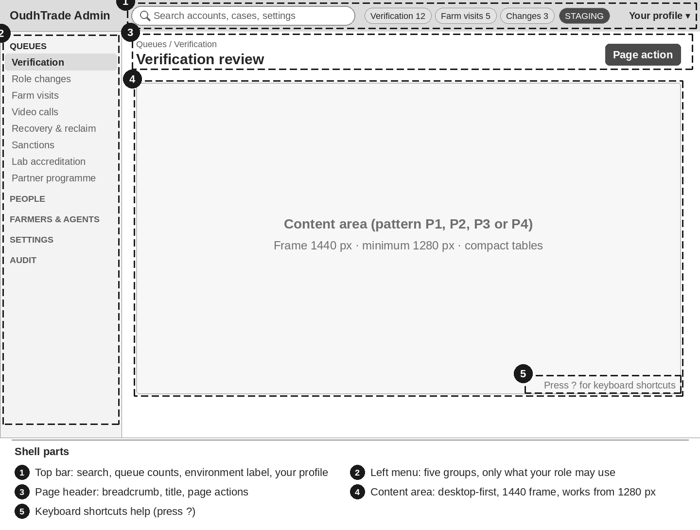
Figure 1 — Admin console shell — top bar, left menu, page header, content area

3.1 Layout
- Top bar: one search (accounts, cases, settings), queue counts for the queues the person works on, environment label (for example "STAGING") on every non-production environment, and Your profile (sign-out, time zone).
- Left menu in five groups — Queues · People · Farmers & agents · Settings · Audit. The menu shows only what the role may use (Section 2).
- Page header: breadcrumb, page title, page actions (one primary action).
- Desktop-first: design 1440 px frames; the console must work from 1280 px. Compact table density and light mode only (decided 26 Sep 2026; UX-UI Foundation §5, "Admin app"). No phone layouts for the console.
- Staff screens use the Operations Console layout (M15) and settings screens the Configuration Console shell (M16). The console has one shared shell look, with Settings as a menu group (decided 26 Sep 2026).

3.2 Menu
Group | Menu items (screen)
Queues | Verification (AD-01, AD-07 tab) · Role changes (AD-04) · Farm visits (AD-05) · Video calls (AD-02) · Recovery & reclaim (AD-06) · Sanctions (AD-03) · Lab accreditation (AD-08) · Partner programme (AD-09)
People | Account lookup (AD-24) · Support view (AD-25) · Invitations (AD-19)
Farmers & agents | Field agents (AD-20) · Farm-visit queue (AD-22) · Quality re-checks (AD-23) · Delegations (AD-21)
Settings | Changes (AD-18) · Document checklists (AD-10) · Business ID rules (AD-11) · Rejection reasons (AD-12) · Setup card items (AD-13) · Role paths & bands (AD-14) · Badge types (AD-15) · Country table (AD-16) · Email domains (AD-17)
Audit | Audit log (M01-6 §12.9 — not in this brief)

3.3 Keyboard and accessibility
Accessibility follows the UX-UI Foundation, Section 11 (WCAG 2.2 AA). For the console in particular:
- Every action works by keyboard; focus order follows the reading order; the focus ring is never hidden by sticky bars.
- Status, flags and countdowns always have words and an icon, never colour alone ("Overdue", not just red).
- Reordering (Up / Down) has buttons, not only drag (M03-6 §16.7).
- Watermarked document images need text alternatives for their controls (zoom, rotate, page list).
- The staff session idle warning follows M02-6 Section 14.
Key (proposal) | Action
J / K | Next / previous row in a queue or list
Enter or O | Open the selected case or row
N | Add an internal note
/ | Go to search
Esc | Close the side panel or dialog
? | Show the shortcut list

No single key makes a decision (accept, reject, approve): every decision needs its reason dialog. The final shortcut list is open question 4.

4. Shared Patterns (Design Once)
Design these four patterns and the common states as Figma templates and components. Every screen page in Section 6 is a variation of one pattern.

4.1 P1 Queue + case review
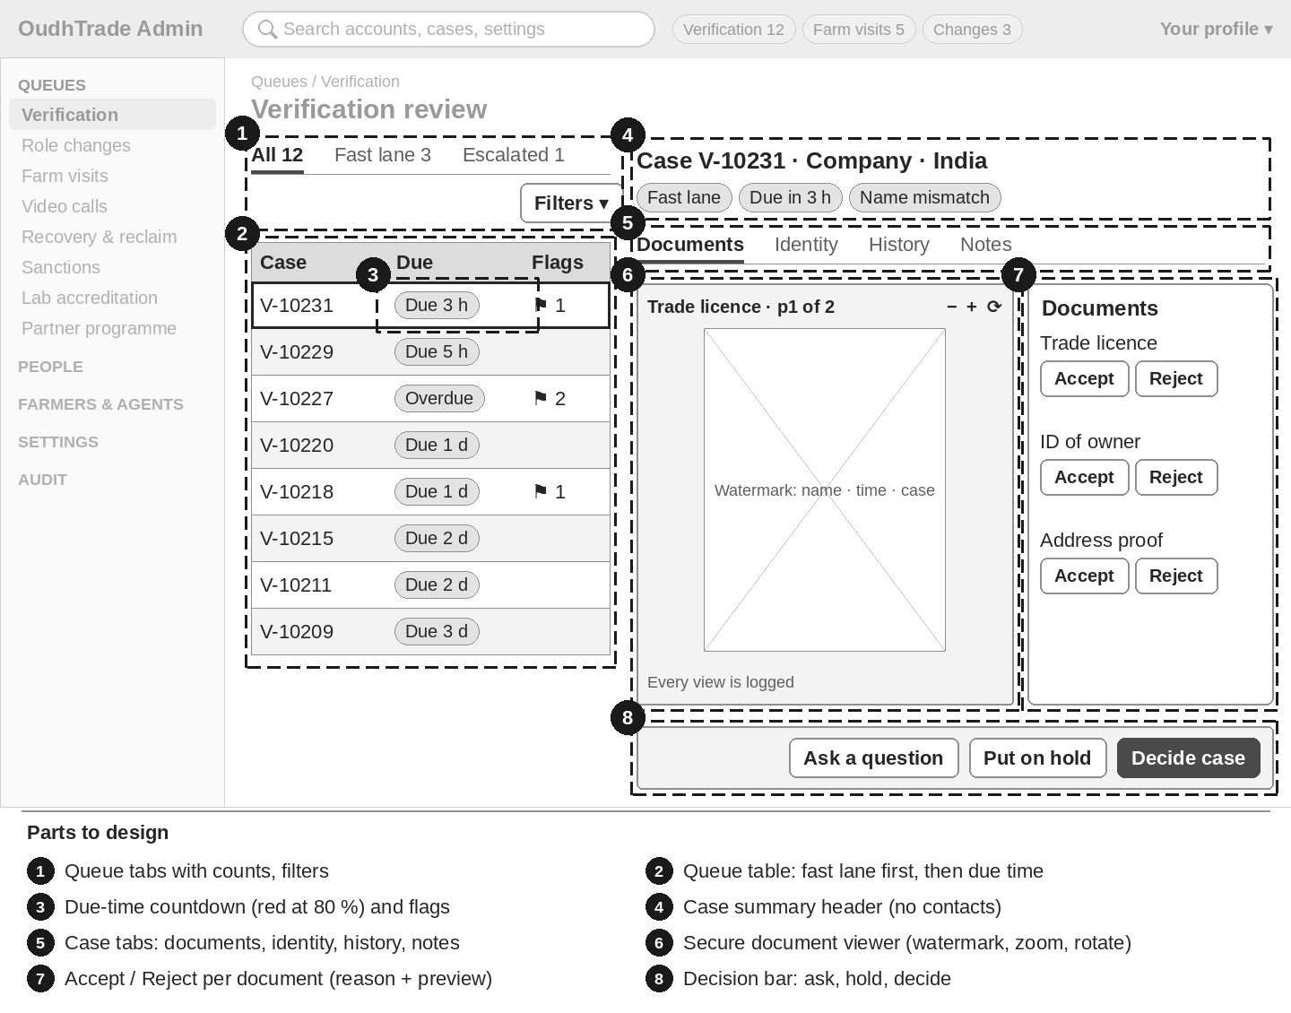
Figure 2 — P1 Queue + case review
Part | What to design | Rules
Queue table | Tabs with counts, filters, columns per screen, flags as icon + word; the open row stays marked | Order: fast lane first, then due time (M03-6 §16.1)
Due-time countdown | "Due in {h} h" chip; turns red at 80 % of the target; "Overdue" after the target | Words + icon, never colour alone
Case view | Summary header (case number, type, role, country, chips), tabs (documents, identity, history, notes), decisions in the last 90 days | No contacts; ID numbers masked only
Secure document viewer | Page images with a watermark (reviewer name, time, case number) across the page; zoom, rotate, page list; banner "Every view is logged." | No download unless the role allows it
Decision bar | Sticky bar: Accept / Reject per document (reason code + message preview), Ask a question, Put on hold, Decide case | Decide works only when every document is decided; hold reason never shown to the user
Reason dialog | Reason list or text, preview of the message the user gets, names who is told | Reason at least 10 characters (M02-6 §20)
Internal notes | Timeline with name and time | Never shown to the user
Edit conflict | Banner "Changed by someone else — please reload." with Reload; typed values stay visible | M01-6 §12.1 step 10

Used by: AD-01 – AD-09.

4.2 P2 Settings editor
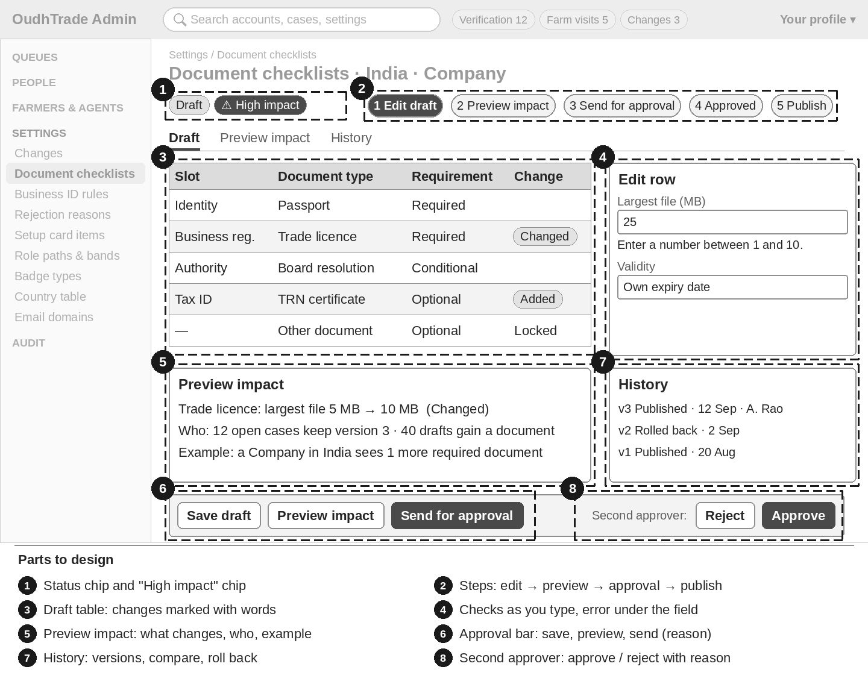
Figure 3 — P2 Settings editor
Step | What to design
1 List | Rows with the published value and a status chip: Published v{n} · Draft · Waiting for approval · Scheduled for {date, time} · Not approved; plus "High impact" on high-impact drafts
2 Edit draft | The live value does not change; checks as you type; error under the field; save and finish later. One draft per item: "{name} has a draft of this since {date}. Open it or wait."
3 Preview impact | Required before sending: what changes (old → new, marked "Added", "Changed", "Retired" with an icon), who is affected (counts), one example
4 Send for approval | Reason required: "Why are you making this change?"
5 Approve or reject | A second person decides, with a reason, on the refreshed preview ("Preview updated {time}")
6 Publish | Publish now or Schedule (IST and the person’s time zone); a scheduled change can be cancelled with a reason
7 History | Every version with status, editor, approver, date and reason; Compare
8 Roll back | Makes a new draft that is approved like any change
9 Staging first | Export in staging; Import in production loads a draft with its preview

Two-level approval (M01-6 §12.1 is the one source)
Level | Editors in this brief | Who approves
High impact | AD-10 E1 · AD-11 E2 · AD-14 paths tab · AD-15 E6 · AD-16 status, features, sign-in and OTP cost cap | A Super Admin who is not the editor
Other | AD-12 E3 · AD-13 E4 · AD-14 bands tab · AD-16 names, time zones, number style, address layout · AD-17 | Any other Admin or Super Admin who is not the editor
Both in one draft | For example AD-14 paths and bands together | The high-impact level

The editor never sees an Approve button on their own change: "You made this change, so another person must approve it." An Admin opening a high-impact change sees: "This change is high impact. A Super Admin must approve it." If an item is not clearly "other", it is high impact.
Used by: AD-10 – AD-18.

4.3 P3 List management
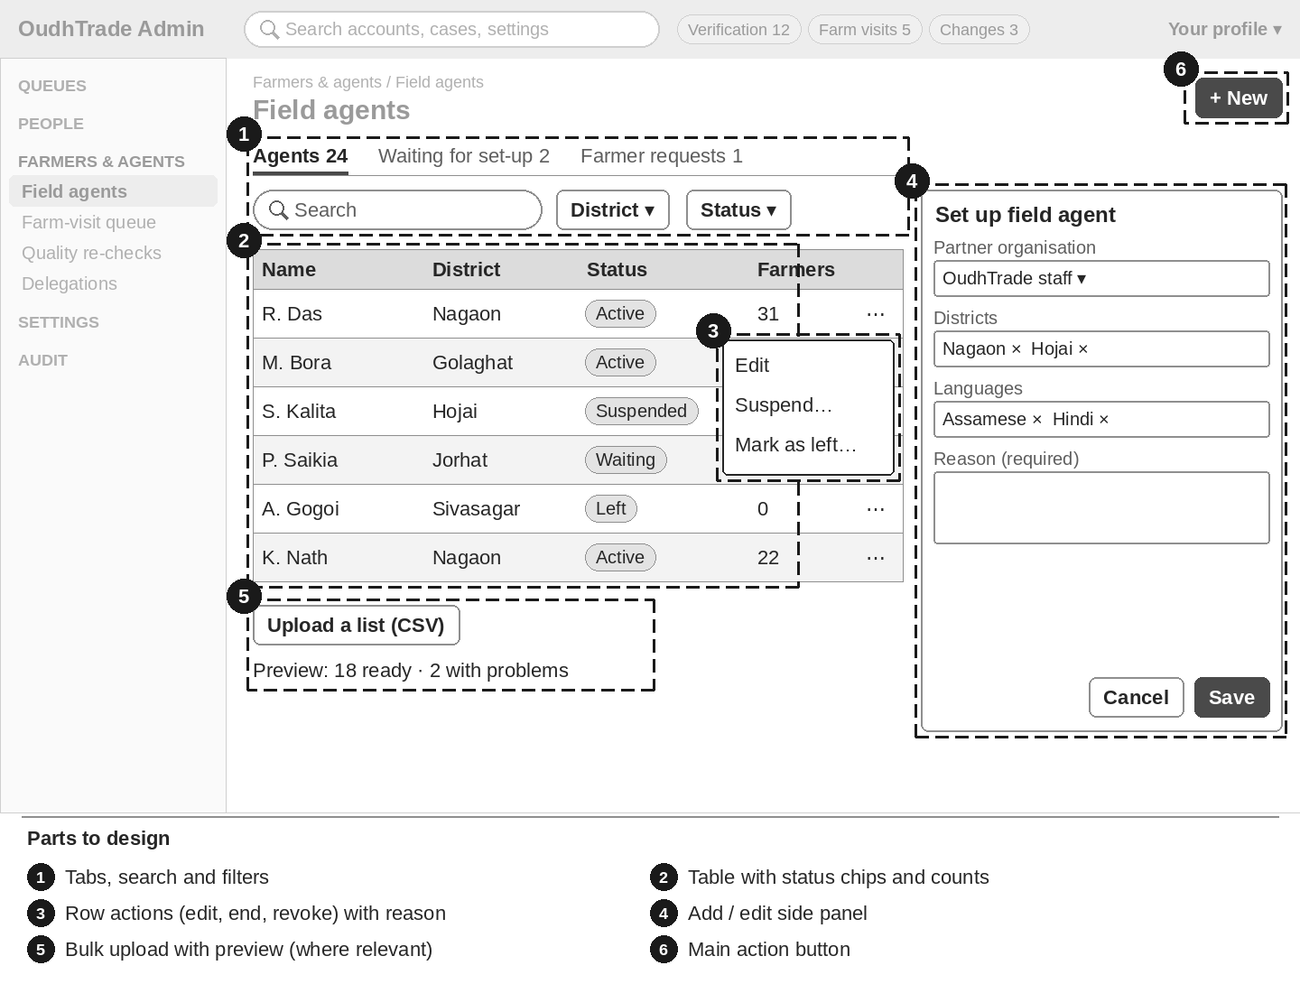
Figure 4 — P3 List management
Part | What to design
Table | Tabs with counts, search, filters, sortable columns, status chips with words
Row actions | Menu per row (edit, suspend, end, revoke, cancel). Every change opens a confirm dialog that says what will happen, names who is told and asks a reason
Side panel | Add / edit form with labels above fields, errors under fields, Save and Cancel
Bulk upload | Where the screen has it: CSV upload, preview "{n} ready · {m} with problems" with the reason per row; only ready rows are sent
Empty and filtered | "Nothing here yet." · "Nothing matches these filters." with Clear filters (M02-6 §20), or the screen’s own text

Used by: AD-19 – AD-23.

4.4 P4 Look-up
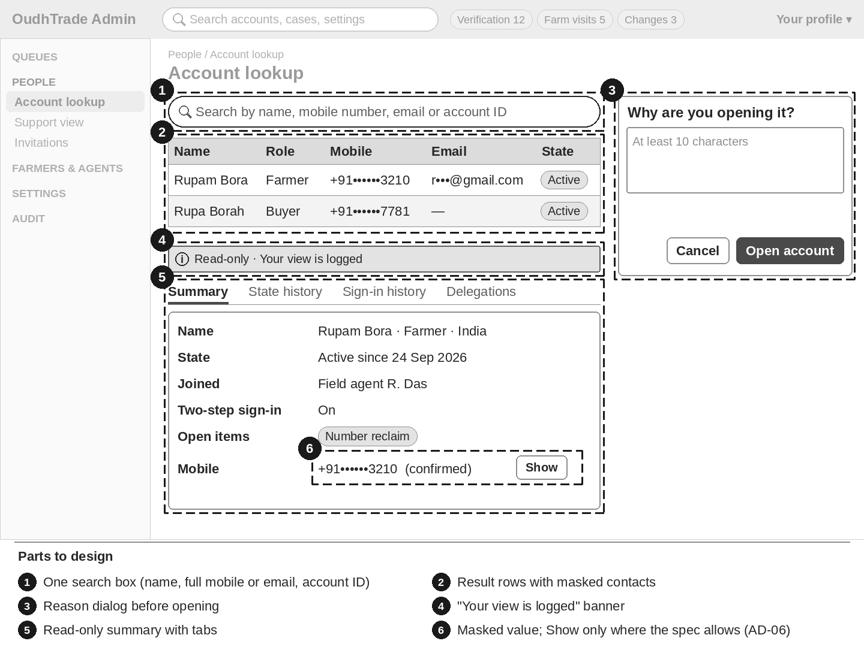
Figure 5 — P4 Look-up
Part | What to design
Search | One box. Names match part of the name (3 letters or more); mobile number and email must be typed in full; account ID matches exactly
Results | Up to 50 rows with masked contacts (+91••••••3210, r•••@gmail.com); "More than 50 accounts match. Add more to your search."
Reason first | Reason dialog before the account opens (at least 10 characters)
Banner | "Your view is logged"; for Support "Read-only · Your view is logged"
Summary and tabs | Read-only summary; extra tabs only for roles that may see them
Masked value with Show | Only where the spec allows it (AD-06 recovery and reclaim cases: Admin and Support): one full contact for 60 seconds, reason asked, logged
No "sign in as" | No screen lets staff sign in or act as a user

Used by: AD-24, AD-25.

4.5 Common states for all screens
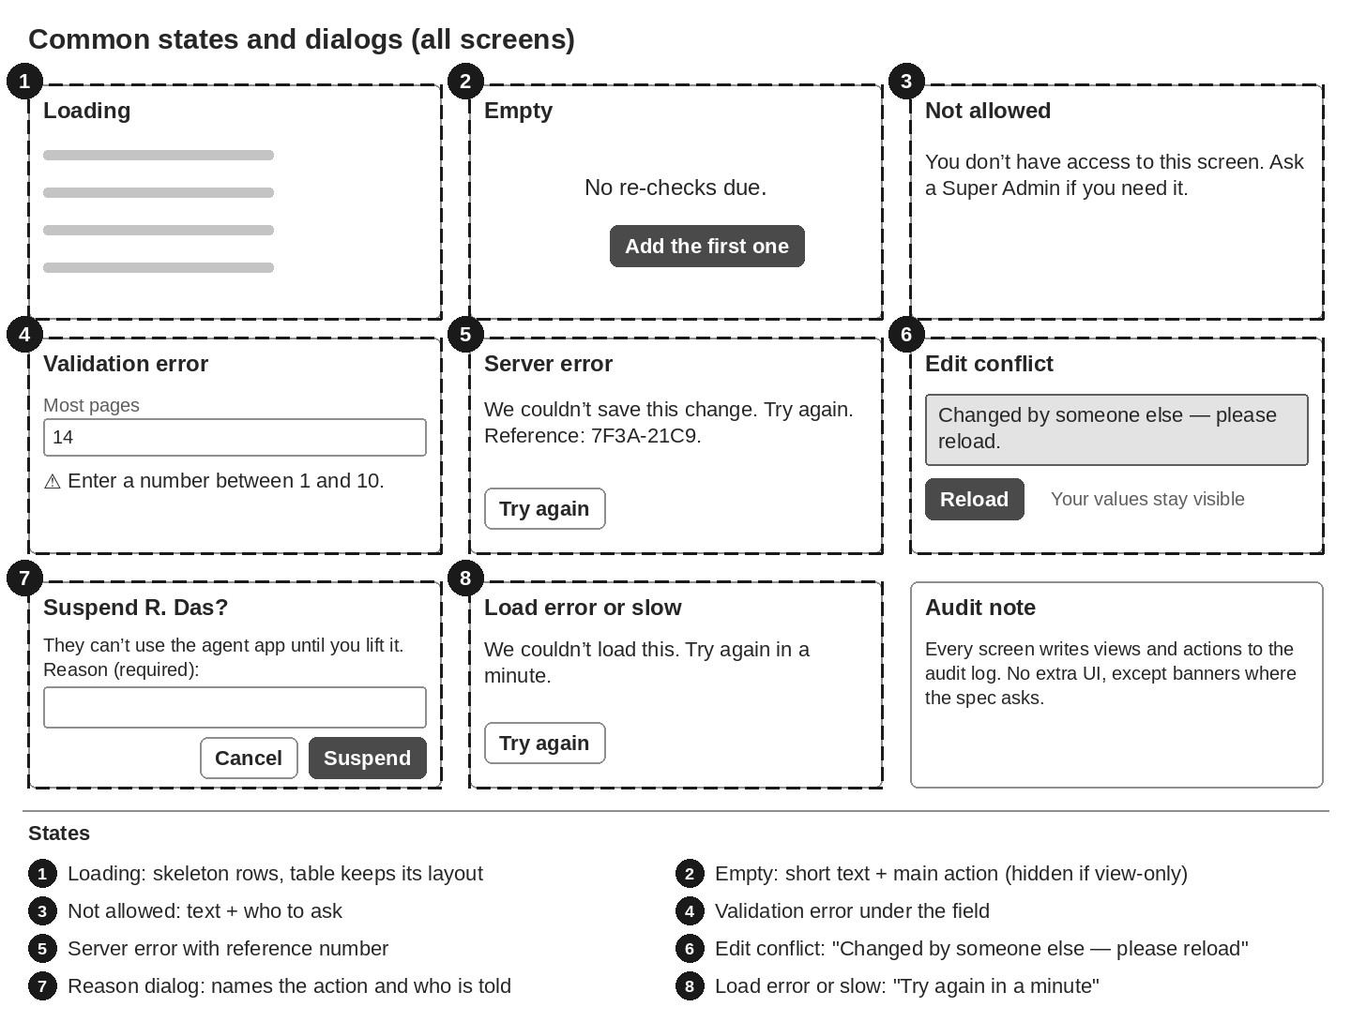
Figure 6 — Common states and dialogs
State | What shows | Source
Loading | Skeleton rows; the table keeps its layout | M01-6 §12.1
Empty | Short text for the screen and the main action (hidden for view-only roles) | Each screen page
Not allowed | "You don’t have access to this screen. Ask a Super Admin if you need it." (STAFF_NOT_PERMITTED) | M01-6 §12.1, M02-6 §19.10
Validation error | Message under each wrong field; Preview impact stays disabled until all fields are valid | M01-6 §12.1
Server error | "We couldn’t save this change. Try again. Reference: {request ID}." The draft is kept | M01-6 §12.1
Load error or slow | "We couldn’t load this. Try again in a minute." with Try again | M02-6 §20
Edit conflict | "Changed by someone else — please reload." with Reload (ROW_CHANGED) | M01-6 §12.1
Session ending | Staff idle warning | M02-6 §14
Audit | Every view and action is logged; no extra UI except the banners the specs name | M02-6 §20

5. Screen Inventory
ID | Screen | Pattern | Users | Priority | Spec
AD-01 | A — Verification review | P1 | Moderator (Senior Moderator for escalations) | P1 | M03-6 §16.1
AD-02 | Video-call ID checks | P1 | Moderator | P2 | M03-6 §16.18
AD-03 | Sanctions batch and match review | P1 | Senior Moderator | P3 | M03-6 §16.13
AD-04 | B — Role change decision | P1 | Admin, Super Admin | P2 | M03-6 §16.3
AD-05 | C — Farm visit review | P1 | Moderator | P1 | M03-6 §16.4
AD-06 | Recovery and number-reclaim review | P1 | Admin, Super Admin (Support: open, note) | P2 | M02-6 §20.2
AD-07 | Staff-awarded badge applications | P1 | Moderator decides; Admin views holders | P3 | M03-6 §16.6
AD-08 | Lab accreditation review | P1 | Moderator | P3 | M03-6 §16.19
AD-09 | Partner programme review | P1 | Admin | P3 | M03-6 §16.20
AD-10 | E1 — Document checklists | P2 | Admin draft, Super Admin approve (high impact) | P1 | M03-6 §16.7
AD-11 | E2 — Business ID rules per country | P2 | Admin draft, Super Admin approve (high impact) | P2 | M03-6 §16.8
AD-12 | E3 — Rejection reasons | P2 | Admin draft, other Admin approve | P2 | M03-6 §16.9
AD-13 | E4 — Setup card items per role | P2 | Admin draft, other Admin approve | P2 | M03-6 §16.10
AD-14 | E5 — Role change paths and capability bands | P2 | Paths: Super Admin approve; bands: other Admin approve | P3 | M03-6 §16.11
AD-15 | E6 — Badge types | P2 | Admin draft, Super Admin approve (high impact) | P3 | M03-6 §16.12
AD-16 | Country table | P2 | Admin draft, Super Admin approve (high-impact fields) | P2 | M01-6 §12.4
AD-17 | Throw-away email domain list | P2 | Admin draft, other Admin approve | P3 | M02-6 §20.7
AD-18 | Changes / approvals | P2 | Super Admin, Admin (Finance: own drafts) | P2 | M01-6 §12.1
AD-19 | Invitations admin | P3 | Admin | P1 | M02-6 §20.3
AD-20 | Field agents | P3 | Admin | P1 | M03-6 §16.16
AD-21 | Delegations overview | P3 | Admin | P3 | M02-6 §20.4
AD-22 | Farm-visit queue by district | P3 | Moderator, Admin | P2 | M03-6 §16.17
AD-23 | Agent and FPO quality re-checks | P3 | Moderator, Admin | P3 | M03-6 §16.15
AD-24 | Account lookup | P4 | Super Admin, Admin, Moderator, Support (read-only) | P2 | M02-6 §20.1
AD-25 | Support profile and case view | P4 | Support (read-only) | P2 | M03-6 §16.21

Related but not in this brief: Staff accounts and roles (M02-6 §20.5) · audit log viewer (M01-6 §12.9) · other M01 settings screens (M01-6 §12.2–12.13) · S15 FPO member farmers, a user screen (M03-6 §14.3).

6. Screen Pages
One section per screen. Each starts with purpose, users and pattern, then the sketch, then what differs (numbers match the sketch), key data, actions, states, rules and the spec section for exact texts.

AD-01 A — Verification review
Item | Brief
Purpose | Moderators check a verification case (business or farmer): documents, identity result and registry result, then decide it. The same screen holds the enhanced-check case view, the badge applications tab and the audit of automatic approvals.
Who uses it | Moderator reviews and decides. Senior Moderator (flag) also takes escalated cases and repeat-rejection cases, and revokes. Admin and Super Admin view only. Support never opens this screen; Support uses the read-only view (AD-25).
Pattern | P1 Queue + case review (Section 4.1) · menu: Queues › Verification · priority P1

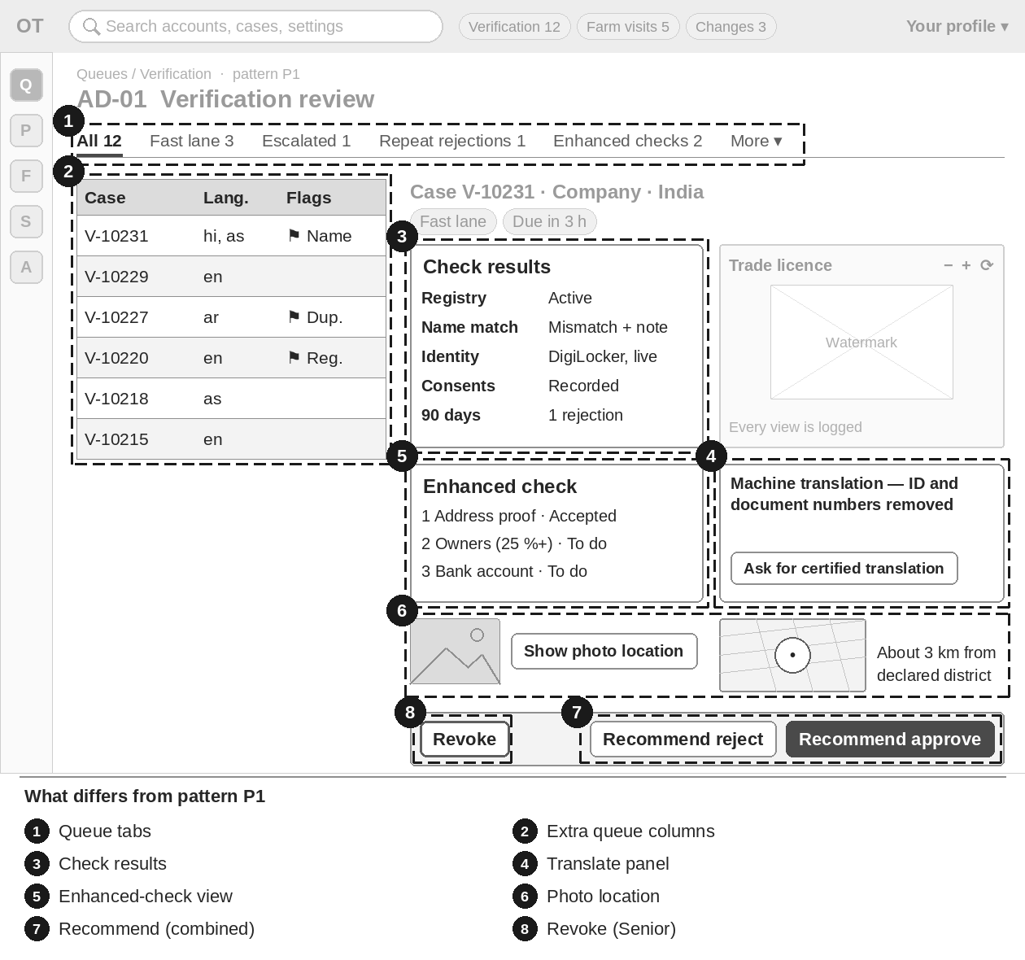
Figure 7 — AD-01 Verification review — numbered boxes show what differs from P1
Item | Brief
What differs (numbers match the sketch) | 1 Queue tabs: All · Assigned to me · Fast lane · Escalated · Repeat rejections · Enhanced checks · Badge applications (AD-07) · Automatic approvals to audit. Escalated and Repeat rejections are for Senior Moderators; the audit tab shows only while automatic approval is switched on.  2 Extra queue columns: fast lane, languages needed and flags (registry, duplicate, name mismatch, forgery warning, repeat rejection). Order: fast lane first, then due time.  3 Case view adds result blocks: registry result, name-match result with the user’s private note, identity result (method, liveness, face match, other route), consents, and decisions and rejections in the last 90 days.  4 Translate opens a side panel "Machine translation — ID and document numbers removed"; Ask for certified translation sends a question to the user.  5 Enhanced-check case view (M03-6 §16.14): three parts, each accepted on its own — 1 Address proof, 2 Owners (25 % or more), 3 Bank account (only when given) — then Pass enhanced check.  6 Show photo location under a photo opens the photo location panel (M01-6 §12.14): reason list and note first, then a small map and the distance to the declared district. No copy or download.  7 Combined case "Role request + verification" (buyer asking to sell): the decision bar shows Recommend approve / Recommend reject with a note instead of Decide case; the case then goes to AD-04.  8 Revoke button for Senior Moderators only (proven forgery; opens an M12 case).
Key data shown | Case number, type, role, country, due time with countdown, flags; profile summary (no contacts); documents per slot with status; ID numbers masked only (never full; for Aadhaar never more than the last 4).
Main actions | Pick case (Assigned to me) · Assign to another Moderator (Senior Moderator) · Per document Accept / Reject (reason from M03-6 §16.2 with message preview) · Ask a question · Put on hold (reason never shown to the user) · Decide case (only when every document is decided) · Revoke (Senior Moderator) · on the audit tab: Audit passed / Problem found with a note.
States | Past 80 % of due time: "Escalated to a Senior Moderator" and the case moves to Escalated. Repeat rejection: "Senior review — repeat rejection". Automatic approval: chip "Approved automatically · audit". Empty tabs have their own text. Plus the common states (Section 4.5).
Rules to respect | Only Senior Moderators take Escalated and Repeat-rejection cases. A hold reason is never shown to the user or to Support. Every document view is logged.
Exact texts and rules | Follow M03-6 §16.1, §16.2, §16.14; messages §20.6, §20.7, §20.14; photo location M01-6 §12.14. Do not copy texts from this brief into designs; use the spec wording.

AD-02 Video-call ID checks
Item | Brief
Purpose | Book and hold a same-gender video call to confirm a user’s identity when a live selfie is not possible or the user refuses it.
Who uses it | Moderator books, holds the call and records the outcome. Admin books. Support only creates a request for a user (from AD-25). Super Admin views.
Pattern | P1 Queue + case review (Section 4.1) · menu: Queues › Video calls · priority P2

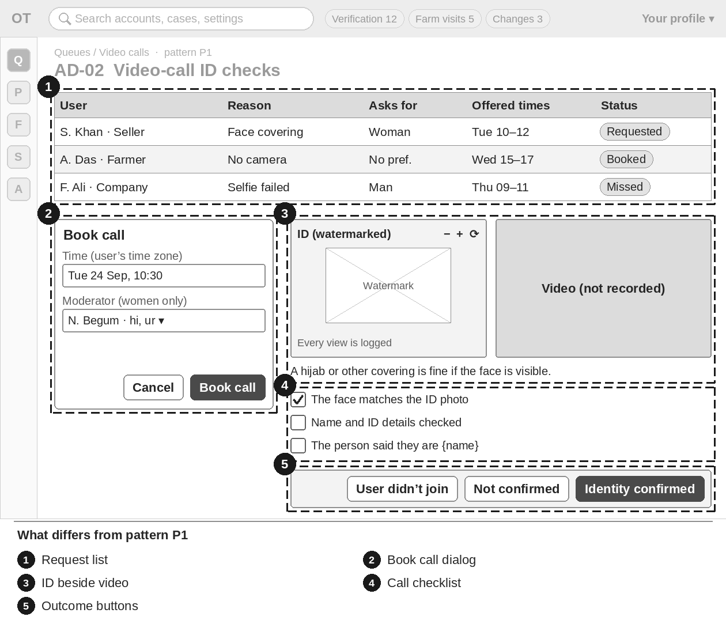
Figure 8 — AD-02 Video-call ID checks — numbered boxes show what differs from P1
Item | Brief
What differs (numbers match the sketch) | 1 The queue is a request list: user (name, role, country, languages) · reason · asked for a woman, a man or no preference · times the user offered (in their time zone) · status Requested · Booked · Done · Missed · Cancelled · due by.  2 Book call dialog: a time and a Moderator. When the user asked for a woman or a man, only Moderators recorded that way (and speaking a user language) are offered.  3 Call view: the user’s ID (watermarked) beside the video area, with the note "A hijab or other covering is fine if the face is visible during the check."  4 Checklist: "The face matches the ID photo" · "Name and ID details checked" · "The person said they are {name}".  5 Outcome buttons instead of a document decision: Identity confirmed · Not confirmed (reason) · User didn’t join.
Key data shown | User, reason, gender preference, offered times, status, due by, booked Moderator.
Main actions | Book call · Change time · Cancel (reason) · Identity confirmed · Not confirmed · User didn’t join.
States | No reviewer free: "No {woman / man} reviewer is free at these times. Offer other times or a field-agent check." Slot taken. After 2 missed calls a field-agent check is suggested. Empty: "No video-call requests."
Rules to respect | The video is never recorded and no screenshot is kept. The call runs in a supplier’s video tool (supplier not chosen yet).
Exact texts and rules | Follow M03-6 §16.18; errors §20.14; user messages §17 ("Video call booked"). Do not copy texts from this brief into designs; use the spec wording.

AD-03 Sanctions batch and match review
Item | Brief
Purpose | The weekly manual check of names against the UN, US (OFAC) and EU lists, and the review of possible matches.
Who uses it | Senior Moderator enters results and clears or confirms matches. Admin and Super Admin view. Other staff have no access (menu item left out).
Pattern | P1 Queue + case review (Section 4.1) · menu: Queues › Sanctions · priority P3

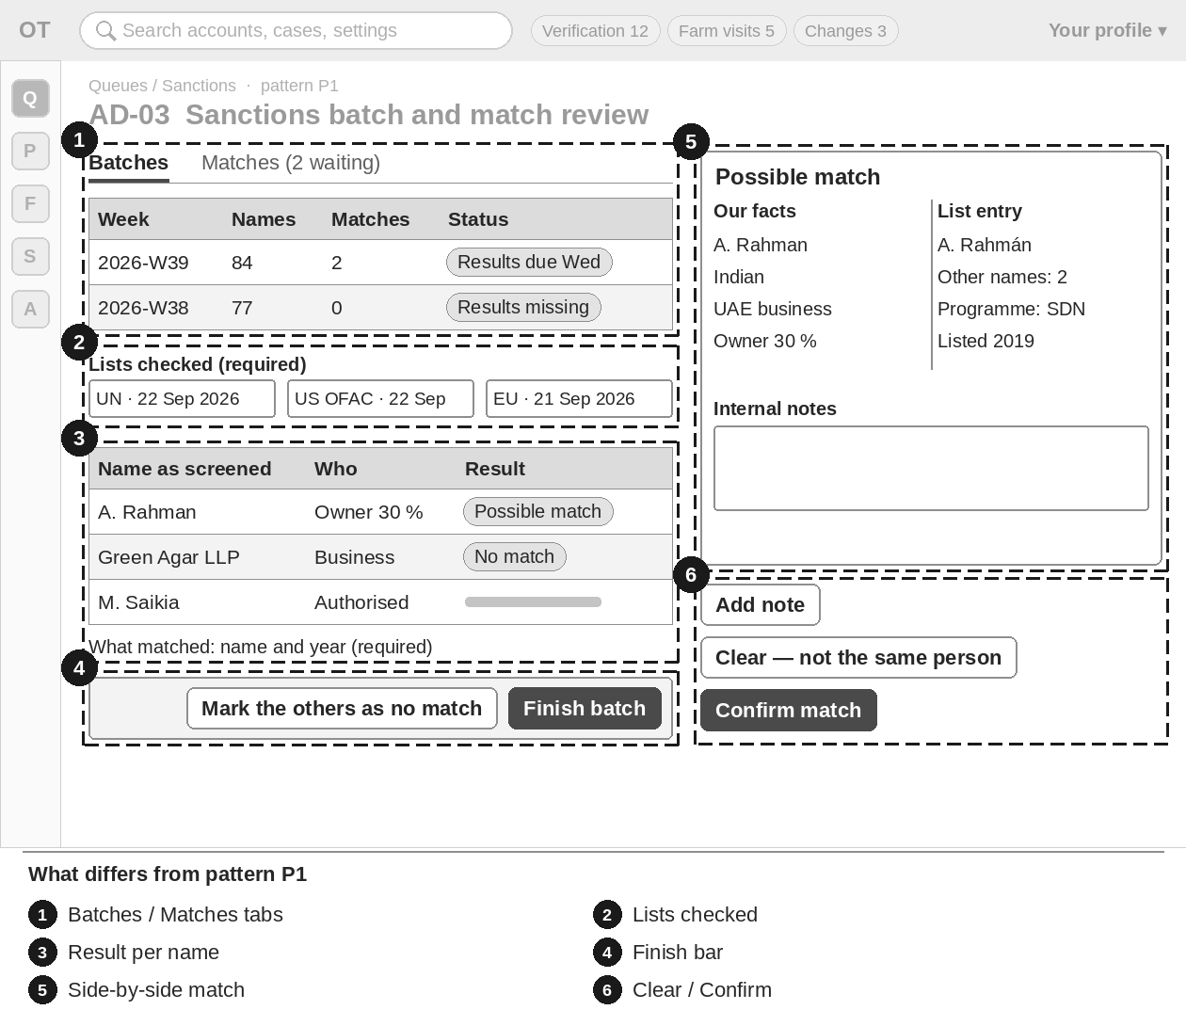
Figure 9 — AD-03 Sanctions batch and match review — numbered boxes show what differs from P1
Item | Brief
What differs (numbers match the sketch) | 1 Tabs: Batches · Matches ({n} waiting). A batch row per week (for example 2026-W39) with status Open · Results due Wednesday · Done and the chip "Results missing".  2 Batch detail header: "Lists checked" fields (UN · US OFAC · EU, each with its list date) — required.  3 One row per name with a result: No match or Possible match (note "What matched" required).  4 Finish bar: Mark the others as no match · Finish batch.  5 Match detail: our facts and the list entry side by side, plus internal notes.  6 Match actions: Clear — not the same person (reason) · Confirm match (reason; opens an M12 case) · Add note.
Key data shown | Week, names, checked, possible matches, status; per match: name and English spelling, who it is, nationality, business country, list entry, days on hold.
Main actions | Enter results · Mark the others as no match · Finish batch · Clear · Confirm match · Add note.
States | Empty: "No batch yet this week. It is made every Monday at 06:00 IST." Chip "Results missing" after Wednesday. Errors for missing lists, results or notes.
Rules to respect | A possible match puts the verification on hold at once; the user sees only "In review". The reason is never shown to the user or to Support, and no action tells the user about sanctions.
Exact texts and rules | Follow M03-6 §16.13; errors §20.14. Do not copy texts from this brief into designs; use the spec wording.

AD-04 B — Role change decision
Item | Brief
Purpose | Decide a user’s request to move to another role (upgrades only), including the buyer who asks to sell, where the role request and the verification are one case.
Who uses it | Admin or Super Admin decides. A Moderator can only recommend (on AD-01, combined case).
Pattern | P1 Queue + case review (Section 4.1) · menu: Queues › Role changes · priority P2

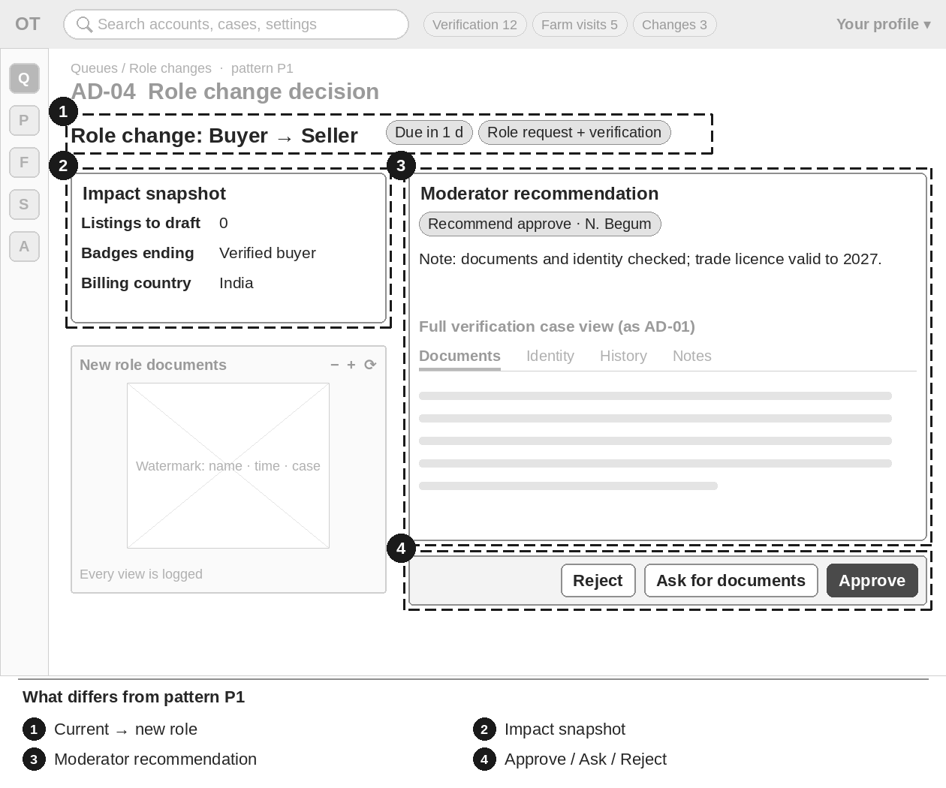
Figure 10 — AD-04 Role change decision — numbered boxes show what differs from P1
Item | Brief
What differs (numbers match the sketch) | 1 Case header shows current role → new role and the due time.  2 Impact snapshot: listings that go back to draft, badges that end, billing country.  3 Combined case: the full verification case view (as AD-01) plus the Moderator’s recommendation and note.  4 Decision bar: Approve · Ask for documents (which and why) · Reject (reason shown to the user with the appeal link). One decision covers role and verification together.
Key data shown | Request, current and new role, impact snapshot, the new role’s documents in the watermarked viewer, due time.
Main actions | Approve · Ask for documents · Reject.
States | Ask for documents moves the case to documents needed; when the user sends again it returns to in review with a new dated expected time. Plus the common states.
Rules to respect | Only upgrade paths set in AD-14 exist. A Moderator never decides here.
Exact texts and rules | Follow M03-6 §16.3; messages §20.10. Do not copy texts from this brief into designs; use the spec wording.

AD-05 C — Farm visit review
Item | Brief
Purpose | Check a field agent’s (or staff member’s) farm-visit report before the "Farm visited" badge is given.
Who uses it | Moderator reviews and decides. Senior Moderator can also mark a visit as found false. Admin and Super Admin view.
Pattern | P1 Queue + case review (Section 4.1) · menu: Queues › Farm visits · priority P1

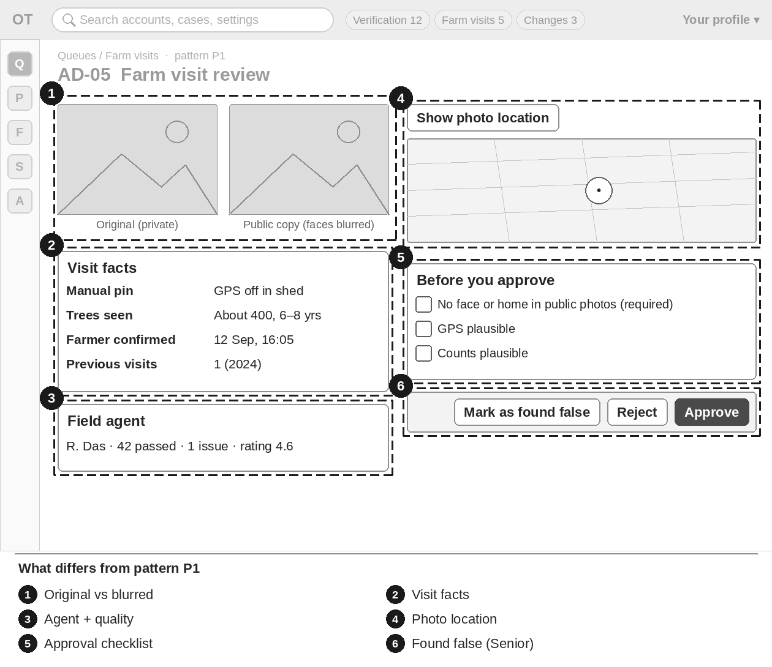
Figure 11 — AD-05 Farm visit review — numbered boxes show what differs from P1
Item | Brief
What differs (numbers match the sketch) | 1 Photo pairs: the private original beside the face-blurred public copy.  2 Visit facts: manual pin reason, tree counts and age observed, farmer confirmation time, previous visits.  3 Agent panel with the agent’s quality record (from AD-23).  4 GPS point and accuracy only through the photo location panel (M01-6 §12.14; reason first, every view logged).  5 Checklist before approval: "No face or home in public photos" (required tick) · GPS plausible · counts plausible.  6 Decision bar: Approve · Reject (reason) · Mark as found false (Senior Moderator only; opens a quality re-check on AD-23 and an M12 case).
Key data shown | Farmer (display name, district), visit date, photos, counts, agent, previous visits.
Main actions | Approve · Reject (reason from E3) · Mark as found false (Senior Moderator).
States | Approve stays disabled until the required tick is set. Plus the common states.
Rules to respect | Photo location is restricted and never public. A staff visit report is reviewed by another person, never by the staff member who made the visit.
Exact texts and rules | Follow M03-6 §16.4; messages §20.8; M01-6 §12.14. Do not copy texts from this brief into designs; use the spec wording.

AD-06 Recovery and number-reclaim review
Item | Brief
Purpose | Decide account recovery and phone-number reclaim cases that need a person.
Who uses it | Admin and Super Admin decide. Support views cases, adds notes and opens ID-check cases (uploading the ID photo and video selfie the user sends), but never decides. The person who opened a case cannot decide it.
Pattern | P1 Queue + case review (Section 4.1) · menu: Queues › Recovery & reclaim · priority P2

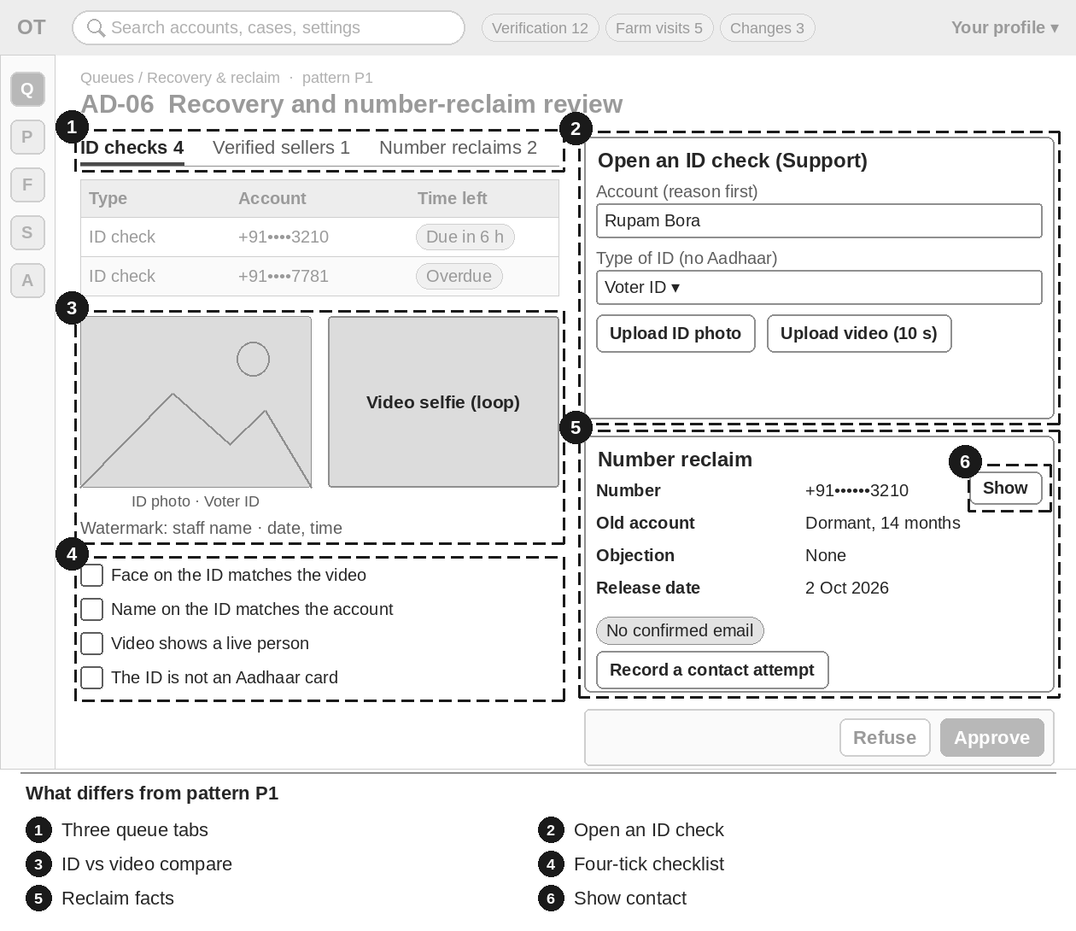
Figure 12 — AD-06 Recovery and number-reclaim review — numbered boxes show what differs from P1
Item | Brief
What differs (numbers match the sketch) | 1 Queue tabs with counts: ID checks · Verified sellers · Number reclaims. Oldest first.  2 Open an ID check form (Support): find the account (reason first) · type of ID (no Aadhaar) · upload ID photo · upload video selfie (up to 10 s) · note.  3 Compare view: ID photo on the left, video selfie on a loop on the right; watermark "{staff name} · {date, time}".  4 Checklist of four ticks; Approve works only when all four are ticked.  5 Reclaim case: masked number, old account facts, chip for why review is needed, objection status, release date; Record a contact attempt.  6 Masked contact with Show: one full contact for 60 seconds, reason required, logged.
Key data shown | Type, account (masked), opened by, opened on, time left, status.
Main actions | Approve (confirm dialog) · Refuse (reason the person sees + note for staff) · Add a note · Open an ID check (Support) · Record a contact attempt · Show.
States | "Due in {hours} h" or "Overdue"; "Expired — not decided in time". Empty: "Nothing waiting for review."
Rules to respect | Staff never see or set a password. Support sees no Approve or Refuse button (left out). Opener cannot decide (REVIEWER_OPENED_CASE).
Exact texts and rules | Follow M02-6 §20.2; errors §19.10; user texts §7.1. Do not copy texts from this brief into designs; use the spec wording.

AD-07 Staff-awarded badge applications
Item | Brief
Purpose | Decide users’ applications for staff-awarded badges and see who holds each badge.
Who uses it | Moderator decides (on the Badge applications tab of AD-01). Admin and Moderators see the list of holders. Admin creates and changes badge types in AD-15.
Pattern | P1 Queue + case review (Section 4.1) · menu: Queues › Verification (Badge applications tab) · priority P3

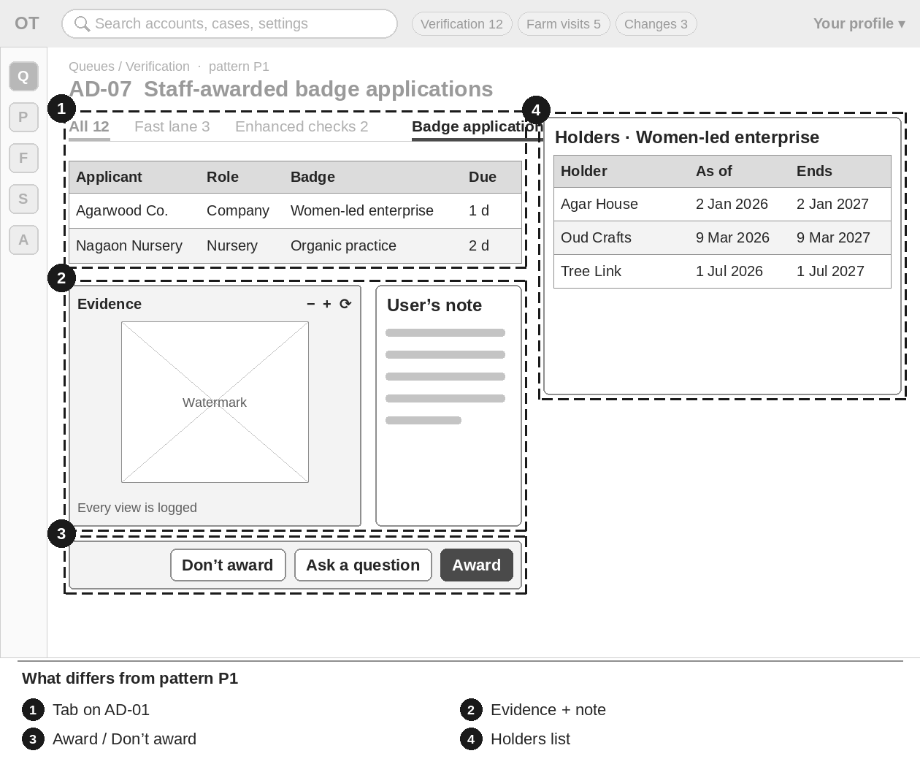
Figure 13 — AD-07 Staff-awarded badge applications — numbered boxes show what differs from P1
Item | Brief
What differs (numbers match the sketch) | 1 It is a tab of the AD-01 queue: applicant · role · badge · due time.  2 Case view: the evidence in the watermarked viewer and the user’s note.  3 Decision bar: Award (the badge gets its "as of" date and end date) · Ask a question · Don’t award (reason from E3, shown to the user).  4 Holders list per badge type (read-only): holder, "as of" date, end date.
Key data shown | Applicant, role, badge, evidence, note, due time; holders with dates.
Main actions | Award · Ask a question · Don’t award.
States | Empty tab: "No badge applications waiting." Plus the common states.
Rules to respect | A retired badge type closes its open applications (AD-15).
Exact texts and rules | Follow M03-6 §16.6; user side §12.10; messages §20.14. Do not copy texts from this brief into designs; use the spec wording.

AD-08 Lab accreditation review
Item | Brief
Purpose | Check a lab’s NABL or ISO/IEC 17025 certificate before the lab is shown as "Accredited lab".
Who uses it | Moderator decides. Senior Moderator can also withdraw. Admin and Super Admin view.
Pattern | P1 Queue + case review (Section 4.1) · menu: Queues › Lab accreditation · priority P3

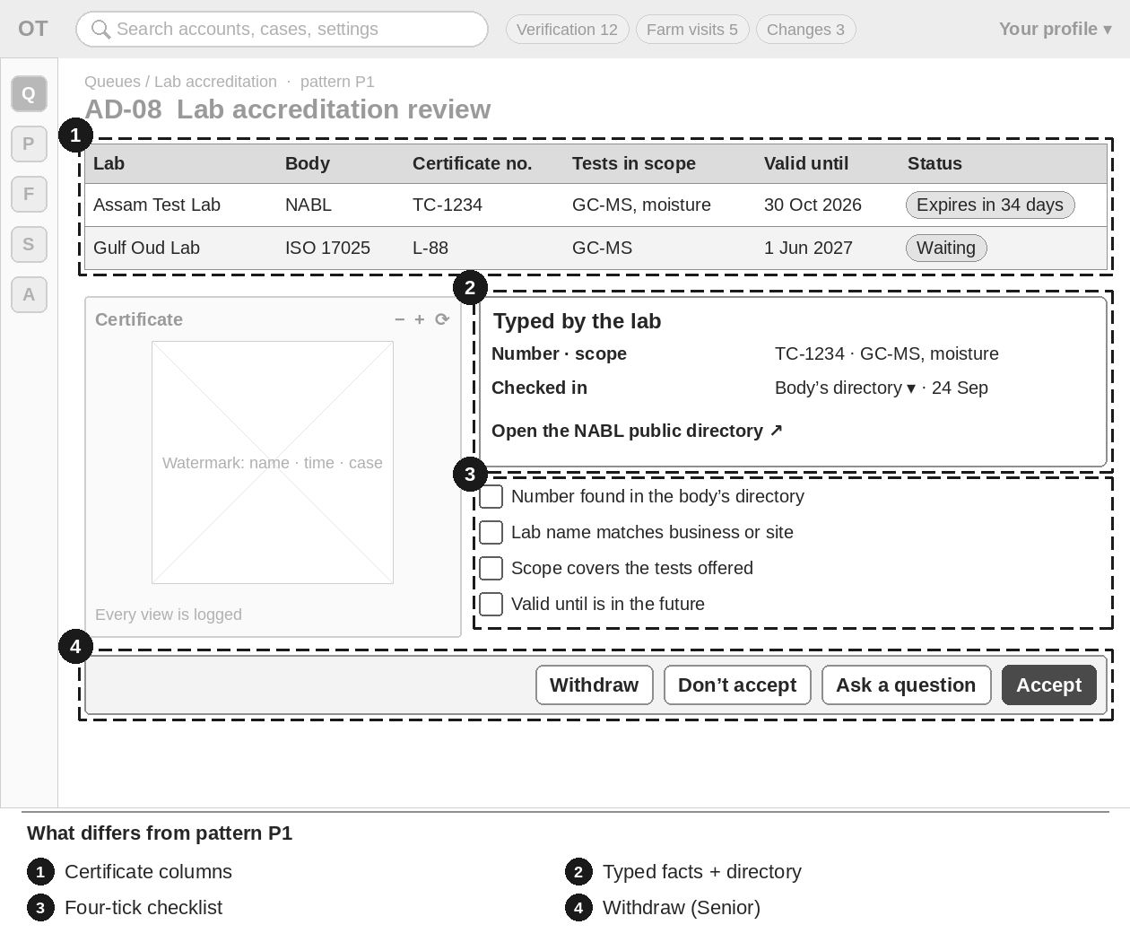
Figure 14 — AD-08 Lab accreditation review — numbered boxes show what differs from P1
Item | Brief
What differs (numbers match the sketch) | 1 Queue columns: body (NABL · other ISO/IEC 17025) · certificate number · tests in scope · valid until · status (Waiting · Accredited · Not accepted · Expired · Withdrawn); chip "Expires in {n} days".  2 Detail: typed number, scope and dates beside the certificate; link to the body’s public directory; field "Checked in" (directory · by hand) with the date.  3 Checklist: number found in the directory · lab name matches · scope covers the tests · valid until is in the future.  4 Decision bar: Accept · Don’t accept (reason) · Ask a question · Withdraw (Senior Moderator).
Key data shown | Lab (store name), body, certificate number, scope, valid until, status, due.
Main actions | Accept · Don’t accept · Ask a question · Withdraw (Senior Moderator).
States | Expired (set by a daily job). Empty: "No lab certificates waiting."
Rules to respect | The badge ends on the valid-until date.
Exact texts and rules | Follow M03-6 §16.19. Do not copy texts from this brief into designs; use the spec wording.

AD-09 Partner programme review
Item | Brief
Purpose | Decide OudhTrade Partner applications and remove partners after upheld complaints.
Who uses it | Admin and Super Admin decide and remove. Moderators view.
Pattern | P1 Queue + case review (Section 4.1) · menu: Queues › Partner programme · priority P3

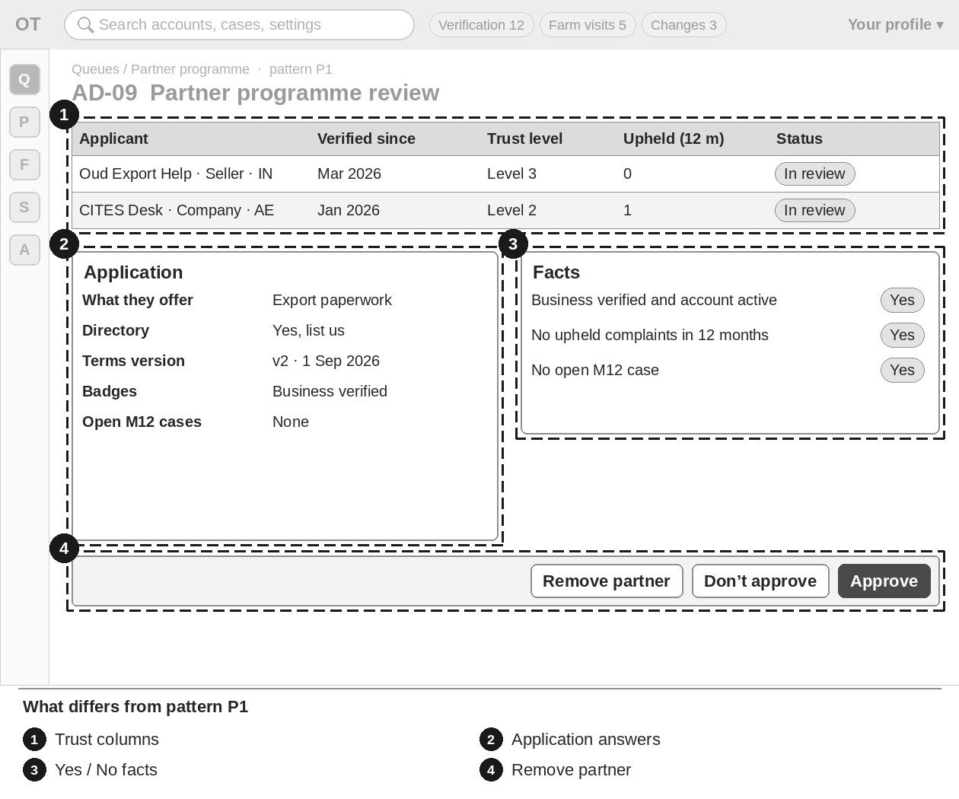
Figure 15 — AD-09 Partner programme review — numbered boxes show what differs from P1
Item | Brief
What differs (numbers match the sketch) | 1 Queue columns: applicant (store, role, country) · verified since · trust level · complaints upheld in 12 months · status (In review · Approved · Not approved · Withdrawn · Removed).  2 Detail: answers, what they offer, directory choice, terms version; profile summary, badges, open M12 cases.  3 Three facts with Yes / No: "Business verified and account active" · "No upheld complaints in the last 12 months" · "No open M12 case".  4 Decision bar: Approve (note required) · Don’t approve (reason) · Remove partner (M12 decision number + reason).
Key data shown | Applicant, verified since, trust level, upheld complaints, applied on, status, due.
Main actions | Approve · Don’t approve · Remove partner.
States | Empty: "No Partner applications waiting."
Rules to respect | Removal always needs an M12 decision number.
Exact texts and rules | Follow M03-6 §16.20; errors M02-6 §19.10. Do not copy texts from this brief into designs; use the spec wording.

AD-10 E1 — Document checklists
Item | Brief
Purpose | Set which documents each role must or may add, per country. It fills the user’s Documents step. Includes the Other-document report (§16.5) with "Add to checklist".
Who uses it | Admin and Super Admin make drafts. High impact: a Super Admin who is not the editor approves. Moderators see the published version read-only.
Pattern | P2 Settings editor (Section 4.2) · menu: Settings › Document checklists · priority P1

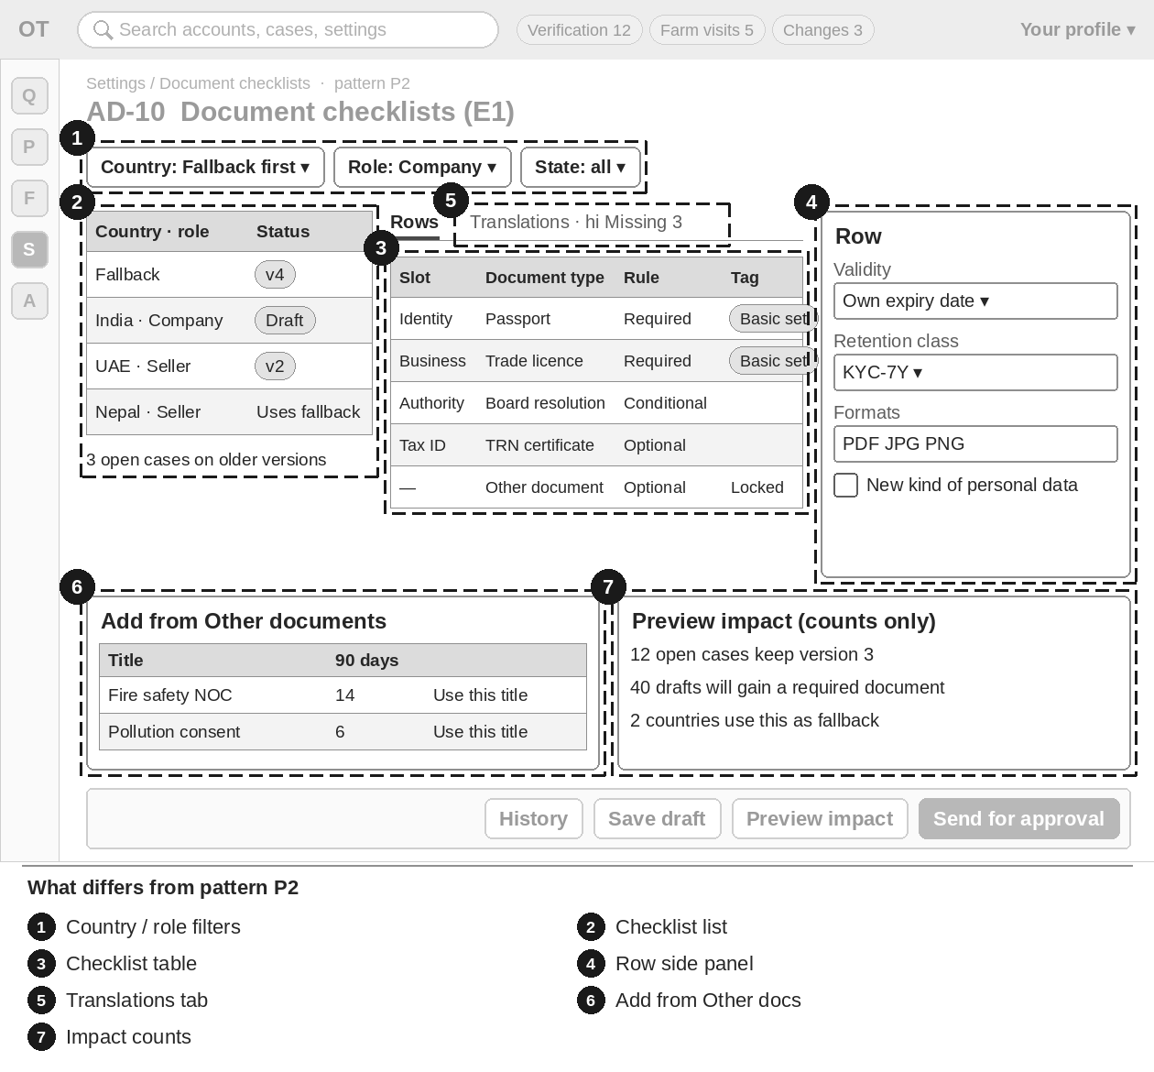
Figure 16 — AD-10 Document checklists (E1) — numbered boxes show what differs from P2
Item | Brief
What differs (numbers match the sketch) | 1 Filters: country ("Fallback — countries without a checklist" first) · role category · state or region.  2 List: one line per country and role with status chip, version, last published, "{n} open cases on older versions" or "Uses fallback".  3 Checklist table in user order; tag "Basic set — can’t be removed"; the last row "Other document" is locked.  4 Row form in a side panel (type, slot, requirement, formats, pages, size, validity, retention class, privacy review, help text, sample image).  5 Translations: a tab per language with Done / Missing (warning only, does not block).  6 Add from Other documents: frequent titles with counts; the report’s Add to checklist opens the same pre-filled row.  7 Preview impact: the "You need" list as users will see it and counts only (open cases keep version, drafts that gain a document).
Key data shown | Country, role, version, status, rows with their rules, open cases on older versions.
Main actions | Edit · Add row · Add from Other documents · Up / Down · Retire row · Copy from another country · plus the P2 steps.
States | No checklist: "No checklist for {country} yet. {Country} uses the fallback list with manual review." with Start a checklist. No frequent titles. Row and field errors next to the row.
Rules to respect | Open cases keep the version they were sent with. Up / Down buttons, not only drag. Basic-set rows and "Other document" cannot be retired. Formats only PDF, JPG, PNG, HEIC/HEIF, WEBP.
Exact texts and rules | Follow M03-6 §16.7, §16.5; checks §20.13; pattern M01-6 §12.1. Do not copy texts from this brief into designs; use the spec wording.

AD-11 E2 — Business ID rules per country
Item | Brief
Purpose | Set the business registration fields and the accepted personal ID types of each country, so nothing country-specific is written into the app.
Who uses it | Admin and Super Admin make drafts. High impact: a Super Admin who is not the editor approves. Moderators view.
Pattern | P2 Settings editor (Section 4.2) · menu: Settings › Business ID rules · priority P2

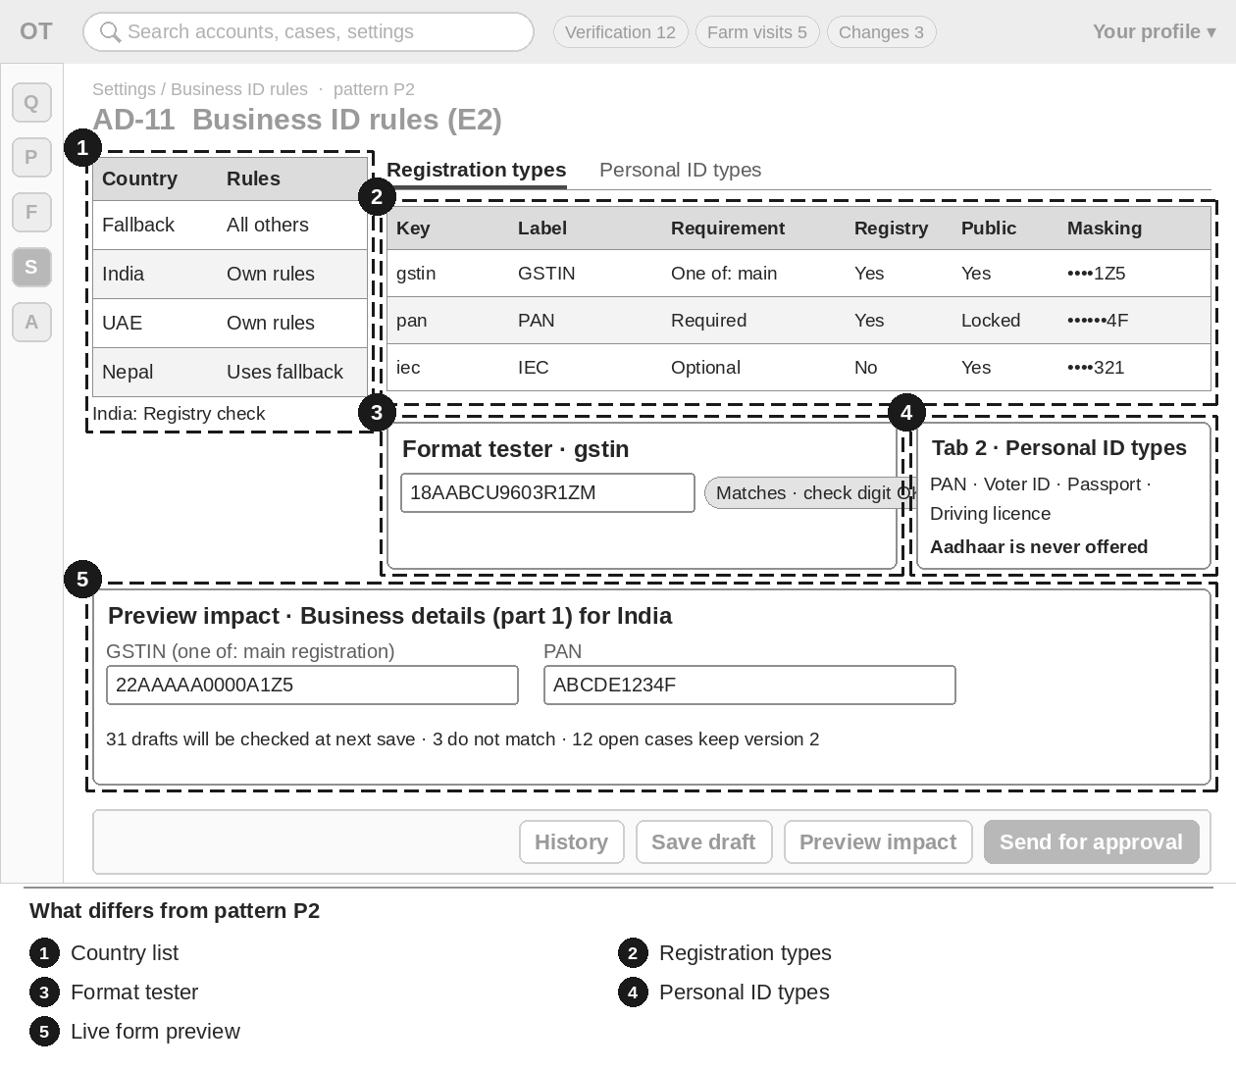
Figure 17 — AD-11 Business ID rules (E2) — numbered boxes show what differs from P2
Item | Brief
What differs (numbers match the sketch) | 1 Country list: "Fallback — every country without its own rules" first; "Own rules" or "Uses fallback"; "Registry check" where available.  2 Tab 1 Registration types: key, label, example, format, check digit, requirement (Required · One of a group · Optional), registry check, public or private, masking.  3 Format tester beside each format: type a value, see "Matches" / "Doesn’t match" and the check-digit result; masking shows a live sample.  4 Tab 2 Personal ID types in order; Add ID type from the Module 3 list. Aadhaar is never offered.  5 Preview impact: a live preview of part 1 of Business details for the country, plus counts of drafts that will not match.
Key data shown | Country, version, status, registration types, personal ID types.
Main actions | Edit · Add registration type · Add ID type · Up / Down · Retire · Copy from another country · plus the P2 steps.
States | "{Country} uses the fallback set." with Add rules. "{Country} uses passport and national ID." Field checks (pattern, example, PAN public, Aadhaar, fallback).
Rules to respect | PAN is always private (switch locked). The fallback set can be edited but never retired. Approved registrations are not re-checked against a new format.
Exact texts and rules | Follow M03-6 §16.8; checks §20.13. Do not copy texts from this brief into designs; use the spec wording.

AD-12 E3 — Rejection reasons
Item | Brief
Purpose | Manage the reasons reviewers pick when they reject a document (AD-01) or a farm visit (AD-05), with the message the user sees.
Who uses it | Admin and Super Admin make drafts. Other setting: any other Admin or Super Admin who is not the editor approves. Moderators view.
Pattern | P2 Settings editor (Section 4.2) · menu: Settings › Rejection reasons · priority P2

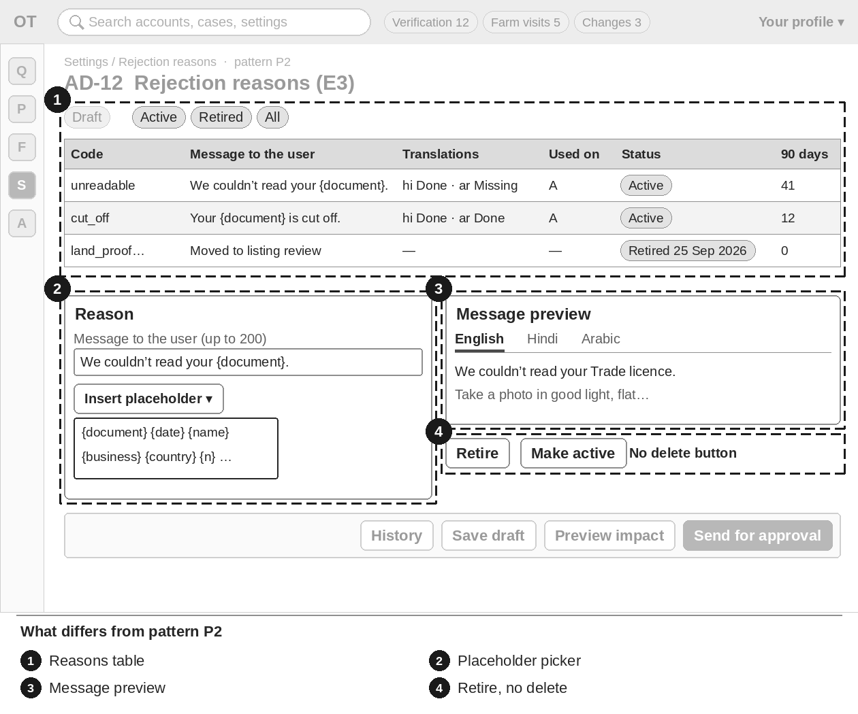
Figure 18 — AD-12 Rejection reasons (E3) — numbered boxes show what differs from P2
Item | Brief
What differs (numbers match the sketch) | 1 Reasons table: code · message · what to send · translations Done / Missing · used on (A, C) · Active / Retired · times used in 90 days; filter and search.  2 Reason form with a placeholder picker ({document}, {date}, {name}…); unknown placeholders refused.  3 Message preview filled with sample values, in each language.  4 Retire / Make active instead of delete; retired rows show "Retired {date}".
Key data shown | Code, message, what to send, translation status, where used, use count.
Main actions | Edit · Add reason · Retire / Make active · plus the P2 steps. No delete button.
States | "No retired reasons." · "No reasons match "{search}"."
Rules to respect | Codes are never deleted. The words "forged", "fake" and "fraud" are refused. The code "other" cannot be retired. Messages already sent do not change.
Exact texts and rules | Follow M03-6 §16.9, starting list §16.2; checks §20.13. Do not copy texts from this brief into designs; use the spec wording.

AD-13 E4 — Setup card items per role
Item | Brief
Purpose | Set which items each role sees on the "Finish setting up" and "Make your profile stronger" cards, in which order, and which step each opens.
Who uses it | Admin and Super Admin make drafts. Other setting: any other Admin or Super Admin who is not the editor approves. Moderators view.
Pattern | P2 Settings editor (Section 4.2) · menu: Settings › Setup card items · priority P2

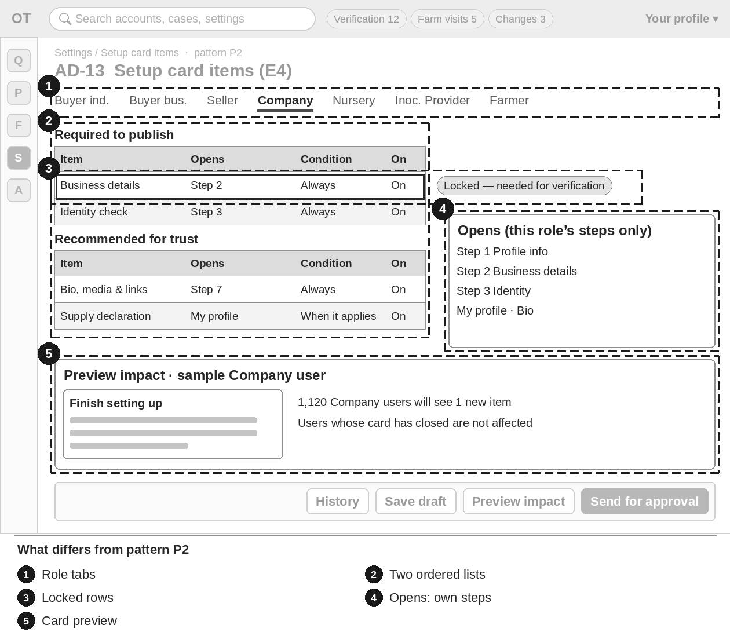
Figure 19 — AD-13 Setup card items (E4) — numbered boxes show what differs from P2
Item | Brief
What differs (numbers match the sketch) | 1 Role tabs: Buyer individual · Buyer business · Seller · Company · Nursery · Inoculation Provider · Farmer.  2 Two ordered lists: Required to publish · Recommended for trust; Move to Required / Recommended; Up / Down.  3 Row: item, time needed, "What to have ready", Opens, Condition, On / Off; locked rows show a lock and the reason.  4 Opens drop-down lists only that role’s wizard steps and My profile sections.  5 Preview impact: the card and the wizard step list for a sample user of the role, with counts.
Key data shown | Role, items with order, time, texts, condition, on/off.
Main actions | Edit · Move to Required / Recommended · Up / Down · Turn off / on · plus the P2 steps.
States | Warning when every Recommended item is off: "{Role} users will not see the "Make your profile stronger" card." (publishing still allowed).
Rules to respect | Buyers have Recommended items only. Items that verification needs stay Required for business selling roles. "Choose a plan" is never Required. A new kind of item needs a code release. Farmer texts need the audio reference.
Exact texts and rules | Follow M03-6 §16.10; checks §20.13. Do not copy texts from this brief into designs; use the spec wording.

AD-14 E5 — Role change paths and capability bands
Item | Brief
Purpose | Turn the allowed upgrade paths on or off, and set the bands that turn private capability figures into public ranges.
Who uses it | Admin and Super Admin make drafts. Tab 1 (paths) is high impact: Super Admin approves. Tab 2 (bands) is another setting: any other Admin approves. A draft touching both needs a Super Admin.
Pattern | P2 Settings editor (Section 4.2) · menu: Settings › Role paths & bands · priority P3

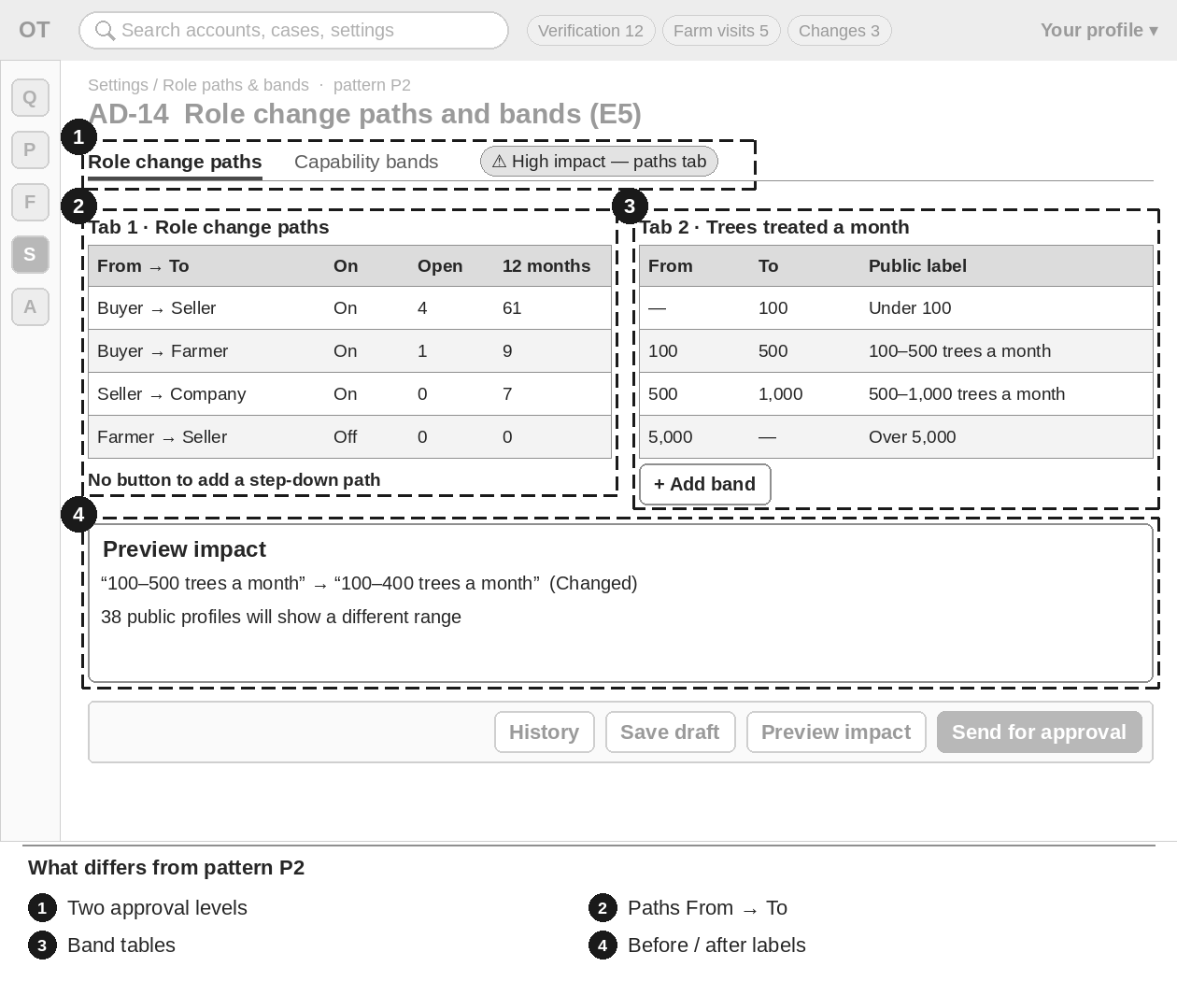
Figure 20 — AD-14 Role change paths and bands (E5) — numbered boxes show what differs from P2
Item | Brief
What differs (numbers match the sketch) | 1 Two tabs with different approval levels; the "High impact" chip shows only for the paths tab (or a draft touching both).  2 Paths table: From → To · On / Off · open requests · requests in 12 months. No button to add a step-down path.  3 Three band tables (trees a month, trees treated so far, seedlings a year): from · to · public label with translations; Add / Remove band.  4 Preview impact: public labels before and after, and "{n} public profiles will show a different range". Counts only.
Key data shown | Paths with counts; bands with labels; counts per band (never a profile’s exact figure).
Main actions | Turn path on / off · Add band · Remove band · plus the P2 steps.
States | "No open requests on this path." · "No capability figures entered yet." Band errors (gap, overlap, order, missing label).
Rules to respect | Only the listed upgrade paths exist. A figure on a boundary belongs to the lower band. Exact figures stay private.
Exact texts and rules | Follow M03-6 §16.11; checks §20.13; starting bands M03-3 §8. Do not copy texts from this brief into designs; use the spec wording.

AD-15 E6 — Badge types
Item | Brief
Purpose | Edit the texts and time settings of the automatic badges, and create staff-awarded badges without code.
Who uses it | Admin and Super Admin make drafts. High impact: a Super Admin who did not create or change the badge type approves. Moderators view.
Pattern | P2 Settings editor (Section 4.2) · menu: Settings › Badge types · priority P3

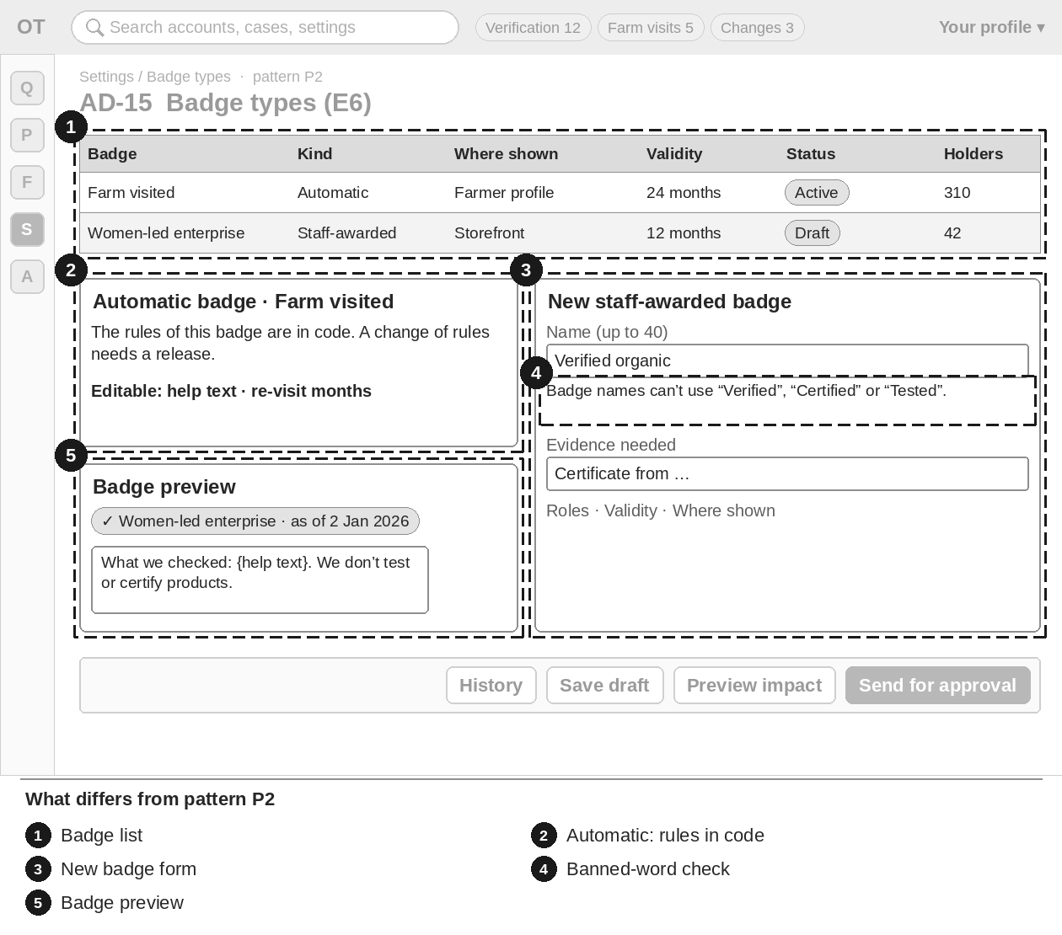
Figure 21 — AD-15 Badge types (E6) — numbered boxes show what differs from P2
Item | Brief
What differs (numbers match the sketch) | 1 Badge list: name · kind (Automatic · Staff-awarded) · where shown · validity · status chip · holders · open applications.  2 Automatic badge panel: "The rules of this badge are in code. A change of rules needs a release." Only help text and time settings can be edited.  3 New staff-awarded badge form: name, help text, evidence needed, roles that can apply, validity, where shown.  4 Name check: "Verified", "Certified" and "Tested" are refused in every language.  5 Badge preview: chip and help pop-up per place and language, with a sample "as of" date.
Key data shown | Badge types, kind, places shown, validity, holders, open applications.
Main actions | New badge · Edit · Retire (staff-awarded only) · plus the P2 steps.
States | "No staff-awarded badges yet." with New badge. Retired rows show "Retired {date}".
Rules to respect | Badges already given keep their dates. Retiring closes open applications; given badges stay until expiry. Automatic badges cannot be created or retired here.
Exact texts and rules | Follow M03-6 §16.12; checks §20.13. Do not copy texts from this brief into designs; use the spec wording.

AD-16 Country table
Item | Brief
Purpose | One row per country: status, selling allowed, launch status, currency, language; detail tabs for general, features, sign-in and states.
Who uses it | Super Admin and Admin edit. Moderator, Finance, Content Editor and Support view only. Status, features, sign-in settings and OTP cost cap are high impact; names, time zones, number style and address layout are other changes.
Pattern | P2 Settings editor (Section 4.2) · menu: Settings › Country table · priority P2

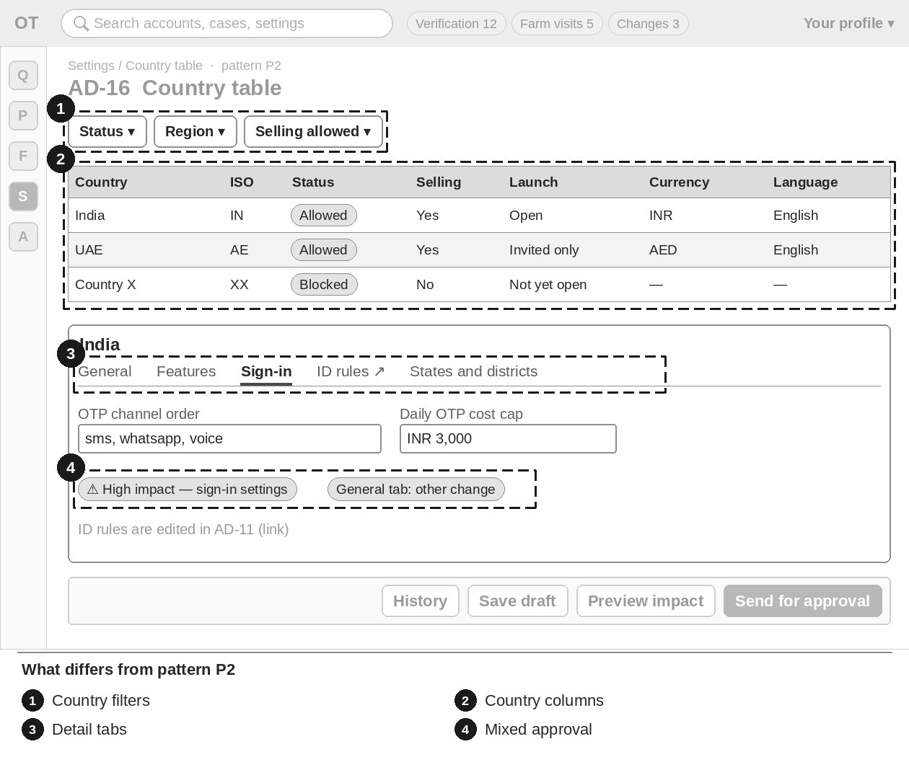
Figure 22 — AD-16 Country table — numbered boxes show what differs from P2
Item | Brief
What differs (numbers match the sketch) | 1 Filters: status · region · selling allowed.  2 Columns: flag, name, ISO code, status (allowed · restricted · blocked), selling allowed, launch status, currency, guide currency, default language.  3 Country detail tabs: General · Features · Sign-in · ID rules (link to AD-11) · States and districts.  4 Approval level differs per tab: "High impact" chip only on drafts that touch high-impact fields.
Key data shown | Country rows and their settings per tab.
Main actions | Edit each tab · plus the P2 steps.
States | "No countries match these filters." "At least one sign-in method is required."
Rules to respect | ID rules are edited only in AD-11 (link, not a copy).
Exact texts and rules | Follow M01-6 §12.4, §12.1. Do not copy texts from this brief into designs; use the spec wording.

AD-17 Throw-away email domain list
Item | Brief
Purpose | Keep the list of throw-away (disposable) email domains refused at sign-up and on email change.
Who uses it | Super Admin and Admin add, retire, import, test and approve other people’s changes. Moderator views and tests. Other roles have no access.
Pattern | P2 Settings editor (Section 4.2) · menu: Settings › Email domains · priority P3

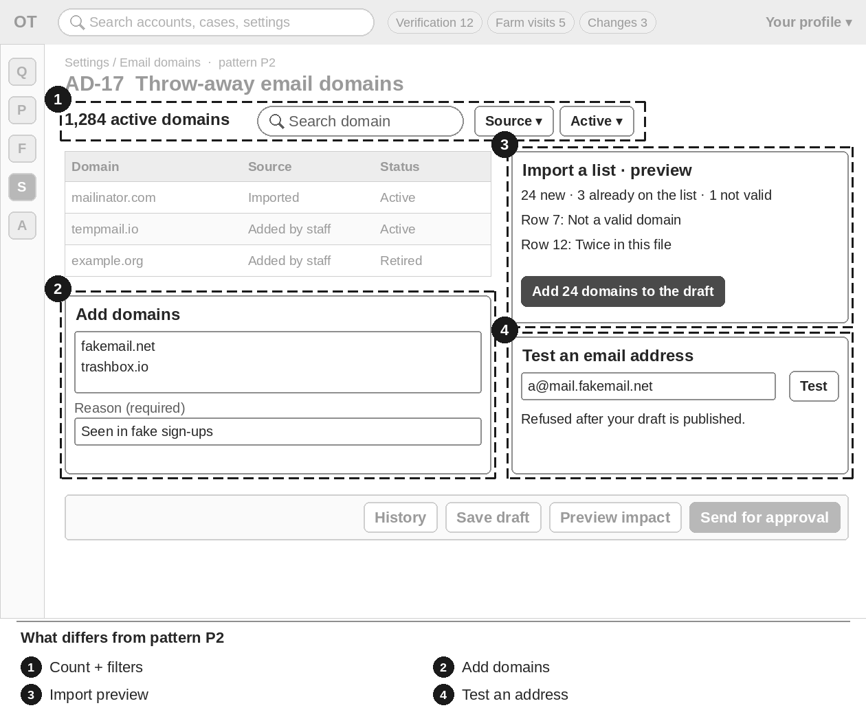
Figure 23 — AD-17 Throw-away email domains — numbered boxes show what differs from P2
Item | Brief
What differs (numbers match the sketch) | 1 Count "{n} active domains", search by domain, filters source and active / retired.  2 Add domains: one per line plus a reason; checked as typed.  3 Import a list with preview "{n} new · {m} already on the list · {k} not valid".  4 Test an email address box with the answer ("Refused — …" / "Allowed — …"); changes nothing.
Key data shown | Domain, source, reason, added by and date, Active / Retired.
Main actions | Add domains · Retire / Make active · Import a list · Test · plus the P2 steps.
States | "No domains on the list yet. Add the first one or import a list." · "No domains match "{search}"."
Rules to respect | Domains are never deleted. Not high impact.
Exact texts and rules | Follow M02-6 §20.7; errors §19.10. Do not copy texts from this brief into designs; use the spec wording.

AD-18 Changes / approvals
Item | Brief
Purpose | One place for every settings change across all modules: waiting for my approval, my drafts, scheduled and recent.
Who uses it | Super Admin and Admin see all four tabs. Finance sees only My drafts.
Pattern | P2 Settings editor (Section 4.2) · menu: Settings › Changes · priority P2

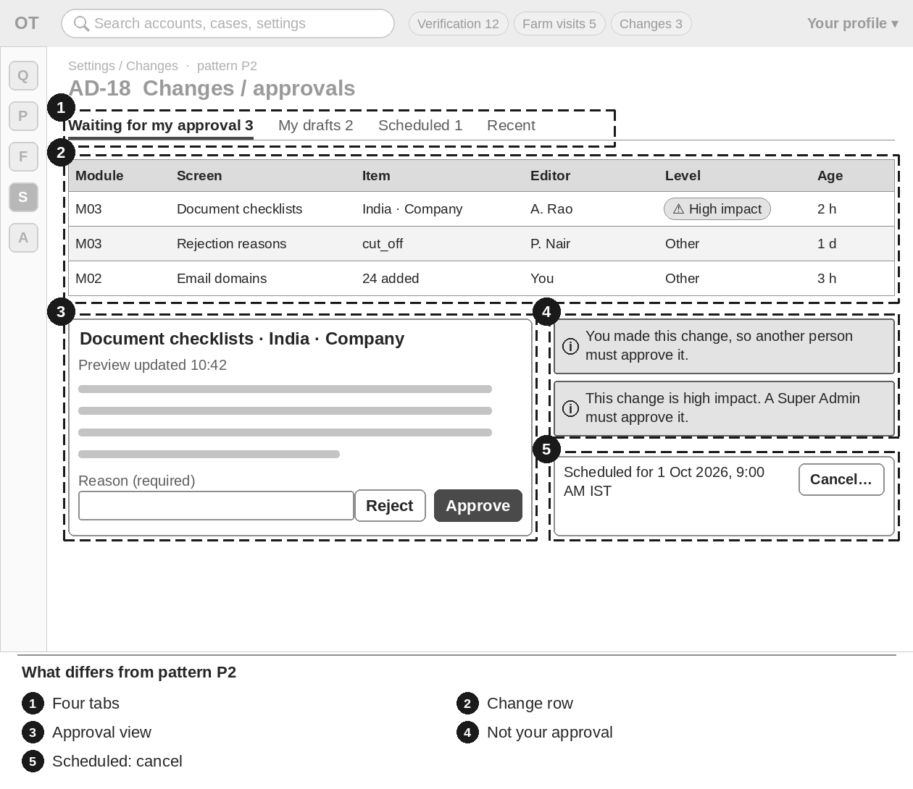
Figure 24 — AD-18 Changes / approvals — numbered boxes show what differs from P2
Item | Brief
What differs (numbers match the sketch) | 1 Tabs: Waiting for my approval · My drafts · Scheduled · Recent (last 90 days).  2 Row: module · screen · item · editor · "High impact" chip · age.  3 Opening a row shows the refreshed preview ("Preview updated {time}") with Approve / Reject, both with a reason.  4 Own change: no Approve button and "You made this change, so another person must approve it." Admin on a high-impact change: "A Super Admin must approve it."  5 Scheduled rows can be cancelled with a reason until they run; times in IST and my time zone.
Key data shown | Module, screen, item, editor, level, age, status.
Main actions | Approve · Reject · Publish now / Schedule · Cancel scheduled change.
States | Empty: "No changes are waiting for your approval." Publish failed. Rejected: chip "Not approved" with the reason.
Rules to respect | Nobody approves their own change. High impact needs a Super Admin who is not the editor.
Exact texts and rules | Follow M01-6 §12.1. Do not copy texts from this brief into designs; use the spec wording.

AD-19 Invitations admin
Item | Brief
Purpose | See and manage every invitation from our team, field agents and FPOs; answer "This isn’t my role" requests; set FPO open-invitation limits.
Who uses it | Super Admin and Admin.
Pattern | P3 List management (Section 4.3) · menu: People › Invitations · priority P1

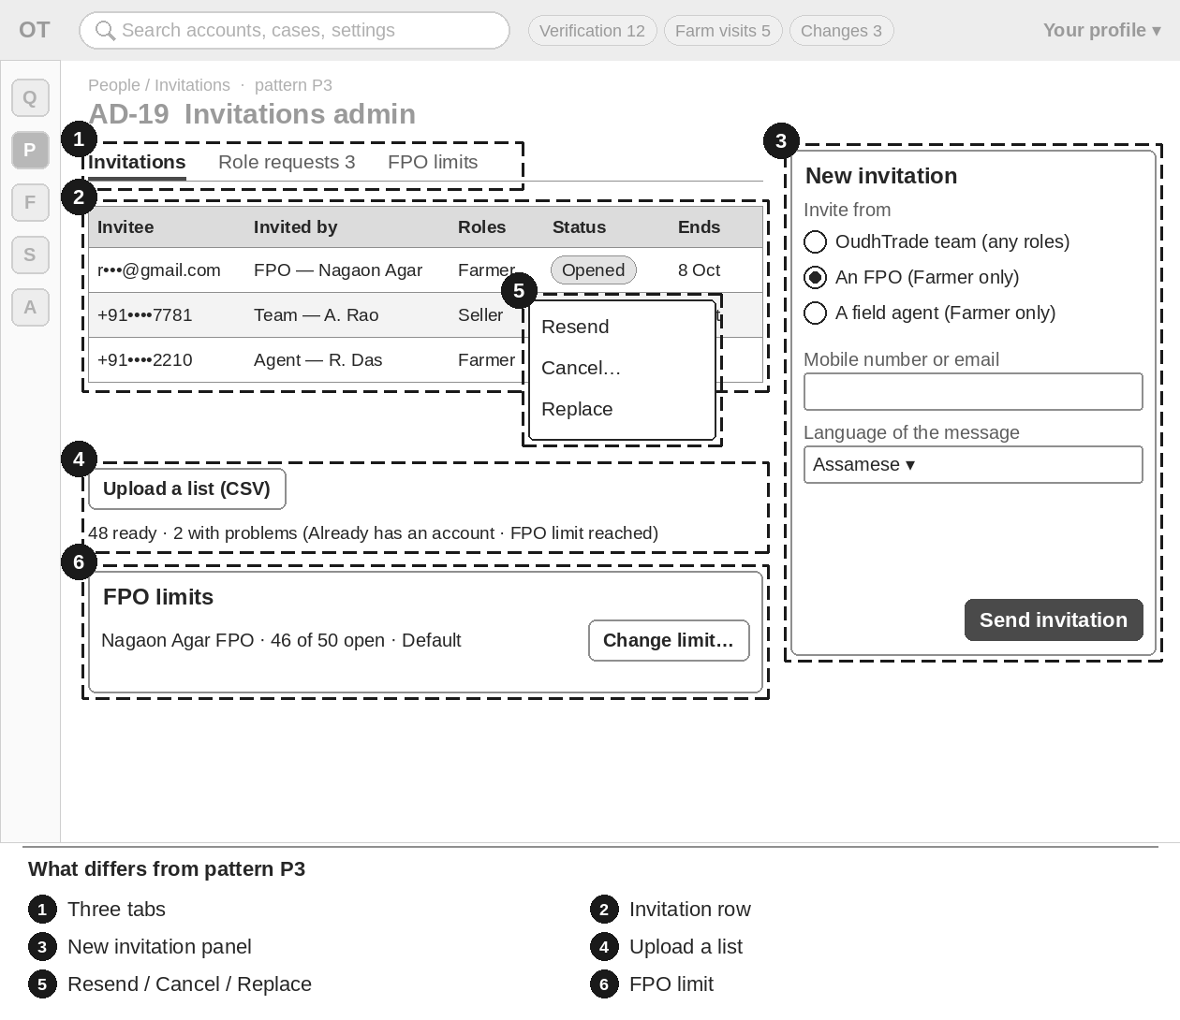
Figure 25 — AD-19 Invitations admin — numbered boxes show what differs from P3
Item | Brief
What differs (numbers match the sketch) | 1 Tabs: Invitations · Role requests ({n} waiting) · FPO limits.  2 Row: invitee (masked) · invited by · allowed roles · status chip (Sent · Opened · Used · Expired · Cancelled · Replaced) · sent on · ends on.  3 New invitation side panel: "Invite from" OudhTrade team · An FPO · A field agent (Farmer only for FPO and agent).  4 Upload a list (CSV) with preview "{n} ready · {m} with problems".  5 Row actions: Resend (once per 24 h) · Cancel (reason) · Replace.  6 FPO limits: "{open} of {limit} open" (starting value 50) and Change limit with a reason.
Key data shown | Invitee, inviter, roles, status, dates; role requests with due chip; FPO limits.
Main actions | New invitation · Upload a list · Resend · Cancel · Replace · Approve / Refuse role request · Change limit.
States | "No invitations match these filters." · "No requests waiting." Limit reached.
Rules to respect | Staff may see "Already has an account"; public screens never say it. Cancelling an FPO invitation gives its place back.
Exact texts and rules | Follow M02-6 §20.3; errors §19.1, §19.10. Do not copy texts from this brief into designs; use the spec wording.

AD-20 Field agents
Item | Brief
Purpose | Set up, approve, edit, suspend and mark field agents as left, and reassign their farmers.
Who uses it | Admin and Super Admin: all actions. Moderators view. The staff account itself is created in Staff accounts (M02-6 §20.5).
Pattern | P3 List management (Section 4.3) · menu: Farmers & agents › Field agents · priority P1

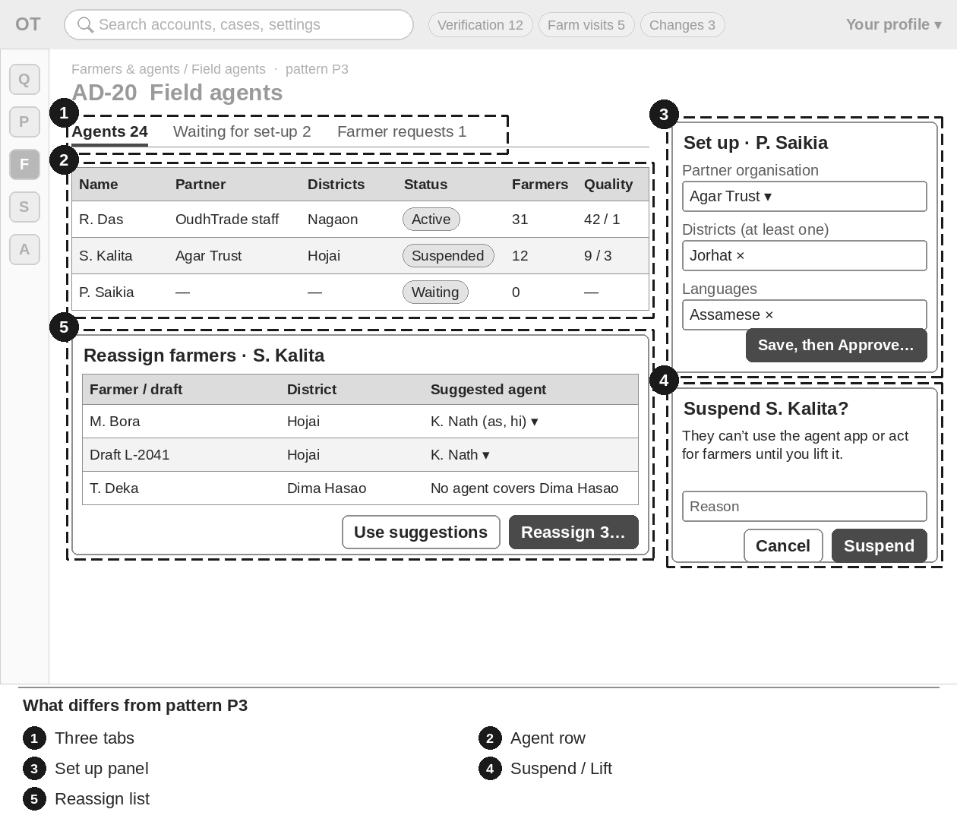
Figure 26 — AD-20 Field agents — numbered boxes show what differs from P3
Item | Brief
What differs (numbers match the sketch) | 1 Tabs: Agents · Waiting for set-up · Farmer requests.  2 Row: name · partner organisation · districts · languages · status (Waiting for approval · Active · Suspended · Left) · farmers · open drafts · quality · last active.  3 Set up side panel: partner organisation · districts (at least one) · languages; then Approve (reason).  4 Suspend (reason) and Lift suspension (reason; M12 decision number after a quality suspension).  5 Reassign farmers: one row per farmer and draft with a suggested new agent; "No agent covers {district}".
Key data shown | Agents with districts, languages, status, farmer and draft counts, quality.
Main actions | Set up · Approve · Edit · Suspend · Lift suspension · Reassign farmers · Mark as left · Keep current agent.
States | "No field agents yet." · "No farmer requests." District required.
Rules to respect | Farmers are told by SMS when reassigned; their help rights to the old agent end.
Exact texts and rules | Follow M03-6 §16.16; errors §20.14. Do not copy texts from this brief into designs; use the spec wording.

AD-21 Delegations overview
Item | Brief
Purpose | See every help right a farmer gave a field agent, and revoke one when needed.
Who uses it | Super Admin and Admin view and revoke. Moderator and Support view only.
Pattern | P3 List management (Section 4.3) · menu: Farmers & agents › Delegations · priority P3

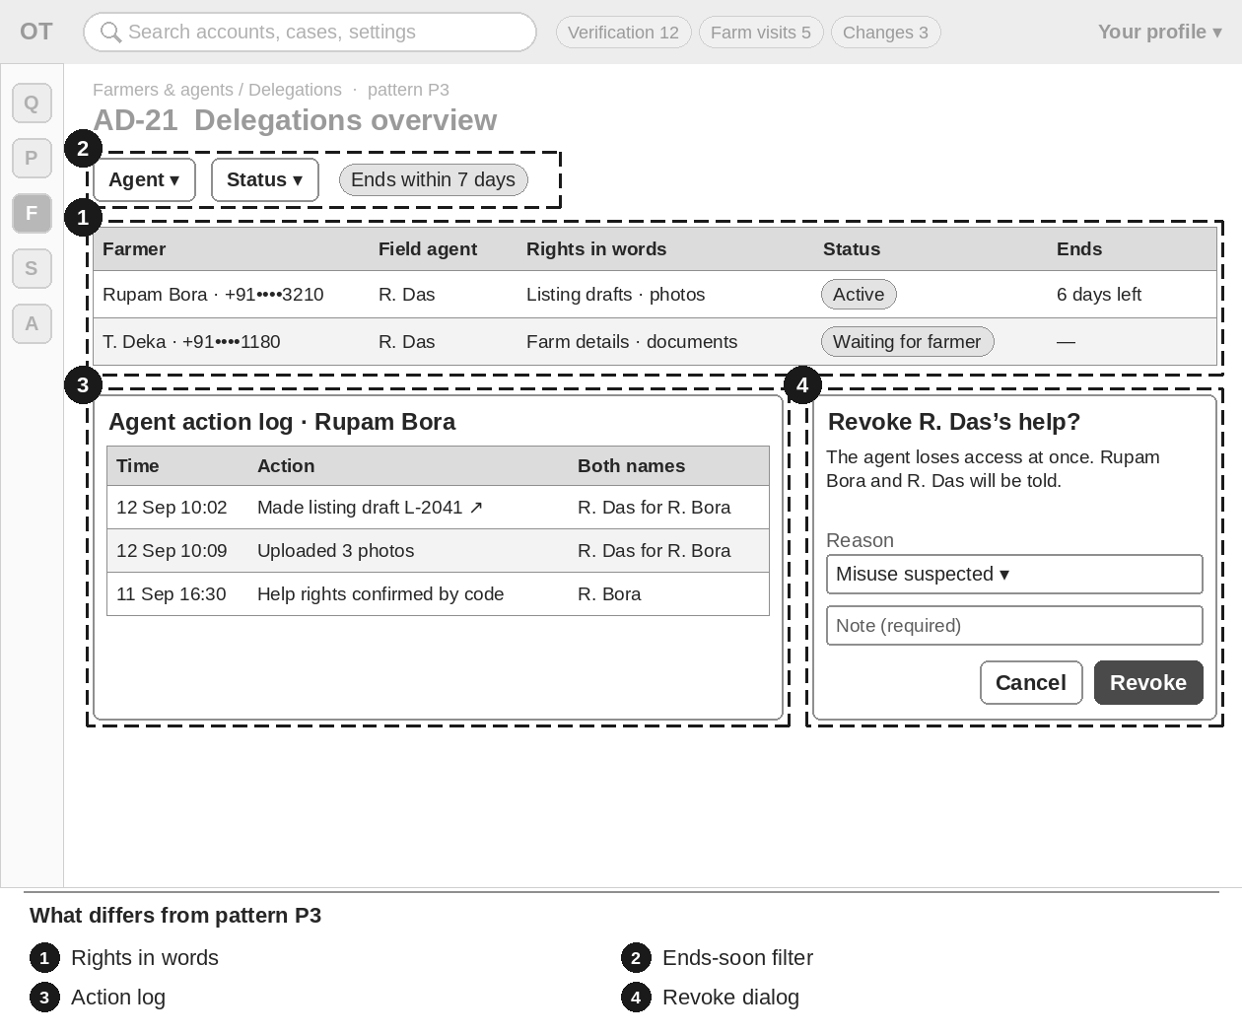
Figure 27 — AD-21 Delegations overview — numbered boxes show what differs from P3
Item | Brief
What differs (numbers match the sketch) | 1 Row: farmer (masked mobile) · field agent · rights in words · status (six states) · started · ends ("{n} days left") · last agent action.  2 Filters: agent · status · "ends within 7 days".  3 Detail: rights asked and given, timeline, agent action log with both names and links.  4 Revoke help rights dialog: reason list plus required note.
Key data shown | Farmer, agent, rights, status, dates, last action.
Main actions | Revoke help rights.
States | "No help rights match these filters."
Rules to respect | When an agent leaves, all their help rights end that day.
Exact texts and rules | Follow M02-6 §20.4. Do not copy texts from this brief into designs; use the spec wording.

AD-22 Farm-visit queue by district
Item | Brief
Purpose | Plan due farm visits by district: first visits, re-visits, quality re-check visits and staff visits where no agent covers the district.
Who uses it | Moderators and Admin assign and offer visits. Super Admin views.
Pattern | P3 List management (Section 4.3) · menu: Farmers & agents › Farm-visit queue · priority P2

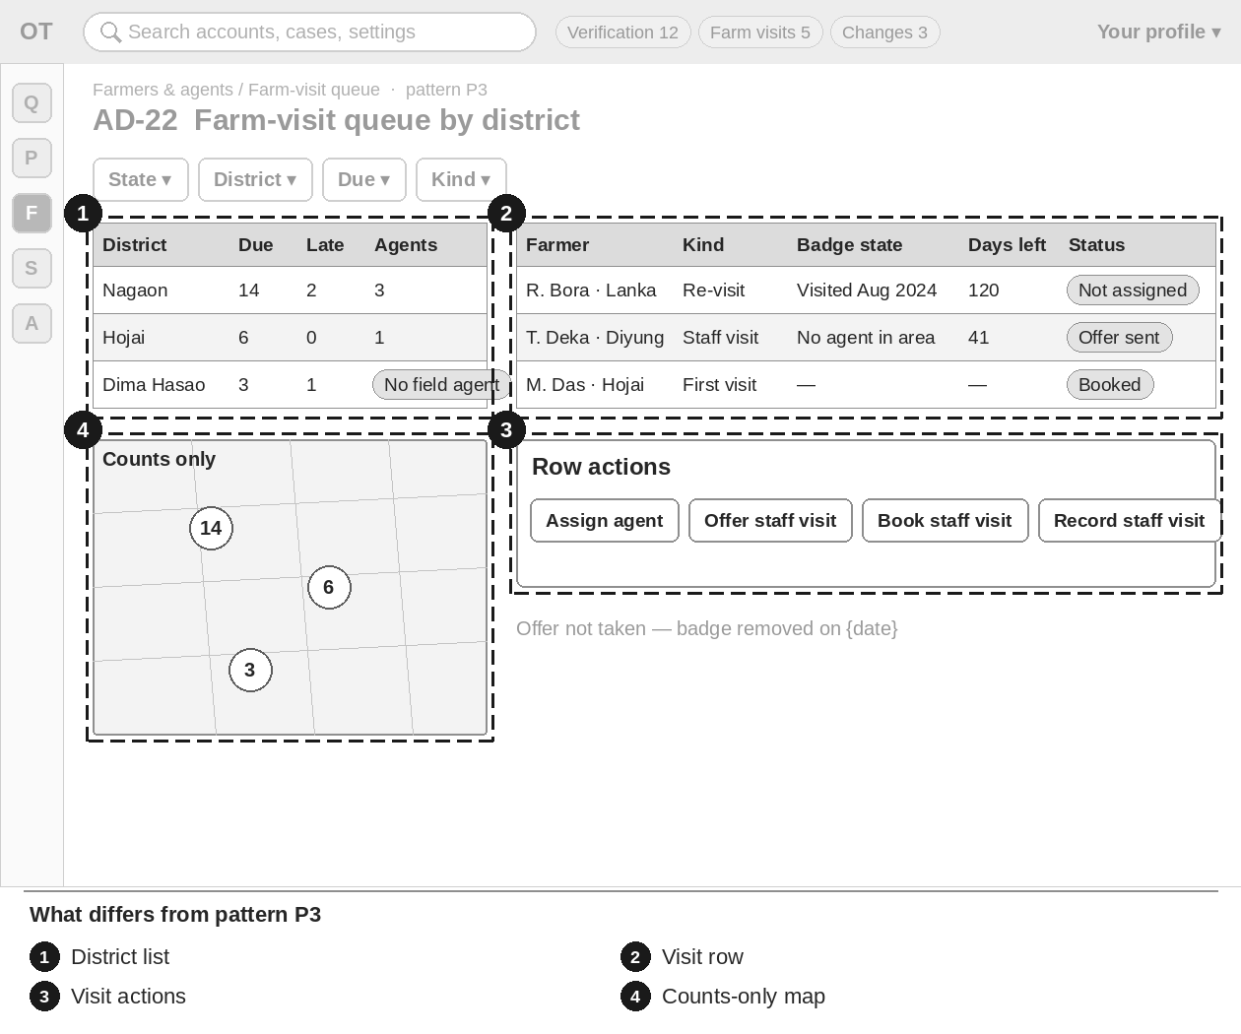
Figure 28 — AD-22 Farm-visit queue by district — numbered boxes show what differs from P3
Item | Brief
What differs (numbers match the sketch) | 1 District list: visits due · overdue · agents covering it · chip "No field agent".  2 Visit row: farmer · kind · last visit · badge state · due on · days left before the badge would be removed · agent · status.  3 Actions: Assign agent · Offer staff visit · Book staff visit · Record staff visit.  4 District map with counts only; photo locations are never shown here.
Key data shown | Districts with counts; visits with kind, badge state, due date, agent, status.
Main actions | Assign agent · Offer staff visit · Book staff visit · Record staff visit.
States | "No visits due in {district}." Offer not taken: "Offer not taken — badge removed on {date}".
Rules to respect | Only agents covering the district can be assigned. The offer starts a 60-day clock. Reports are reviewed on AD-05 by another person.
Exact texts and rules | Follow M03-6 §16.17. Do not copy texts from this brief into designs; use the spec wording.

AD-23 Agent and FPO quality re-checks
Item | Brief
Purpose | Run the random 10 % re-checks of farmers confirmed by field agents and FPOs, and the re-checks after a proven fake.
Who uses it | Moderators assign checkers and record outcomes. Only a Senior Moderator records a fake confirmation. Admin assigns and lifts suspensions. Super Admin views.
Pattern | P3 List management (Section 4.3) · menu: Farmers & agents › Quality re-checks · priority P3

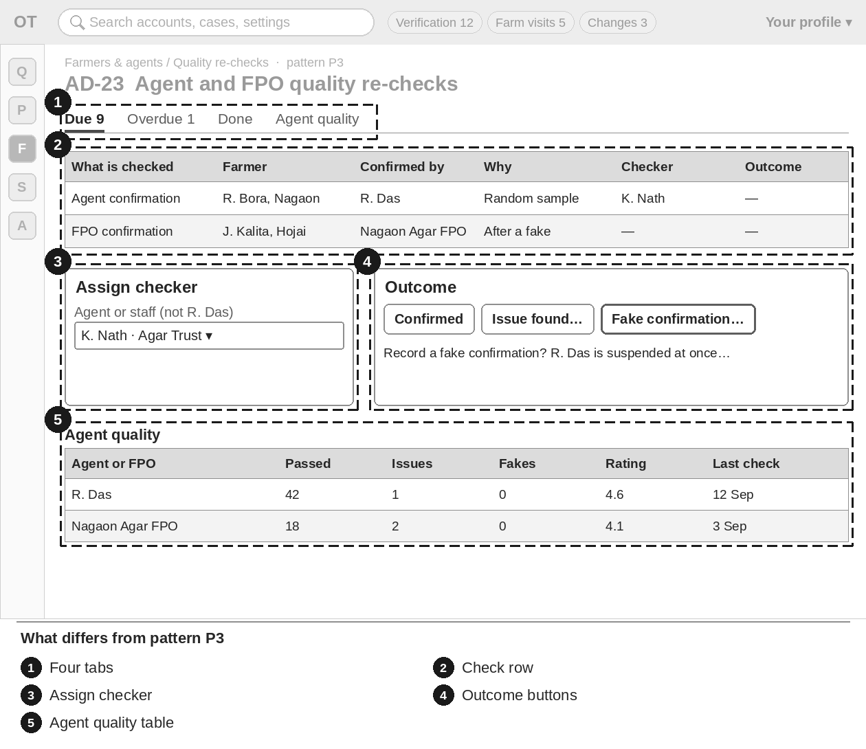
Figure 29 — AD-23 Agent and FPO quality re-checks — numbered boxes show what differs from P3
Item | Brief
What differs (numbers match the sketch) | 1 Tabs: Due · Overdue · Done · Agent quality.  2 Row: what is checked · farmer · confirmed by · why · due on · checker · outcome.  3 Assign checker: another field agent or a staff member; never the agent whose work is checked.  4 Outcome: Confirmed · Issue found (note) · Fake confirmation (Senior Moderator; warning dialog).  5 Agent quality table: checks passed · issues · fakes · rating · last check.
Key data shown | Checks with farmer, confirmer, reason, checker, outcome; quality per agent and FPO.
Main actions | Assign checker · Record outcome · Lift suspension (Admin, needs the M12 decision number).
States | Empty: "No re-checks due." Suspended agent or FPO shown with status chip.
Rules to respect | A fake confirmation suspends the agent or FPO at once and starts re-checks of all farmers they confirmed; those farmers keep their badge until their own re-check.
Exact texts and rules | Follow M03-6 §16.15; errors §20.14. Do not copy texts from this brief into designs; use the spec wording.

AD-24 Account lookup
Item | Brief
Purpose | Find an account and see its summary. Admin actions exist only to carry out an M12 decision, the under-18 rule and data-rights requests.
Who uses it | Super Admin and Admin: full view and actions. Moderator: full view, no actions. Support: read-only summary.
Pattern | P4 Look-up (Section 4.4) · menu: People › Account lookup · priority P2

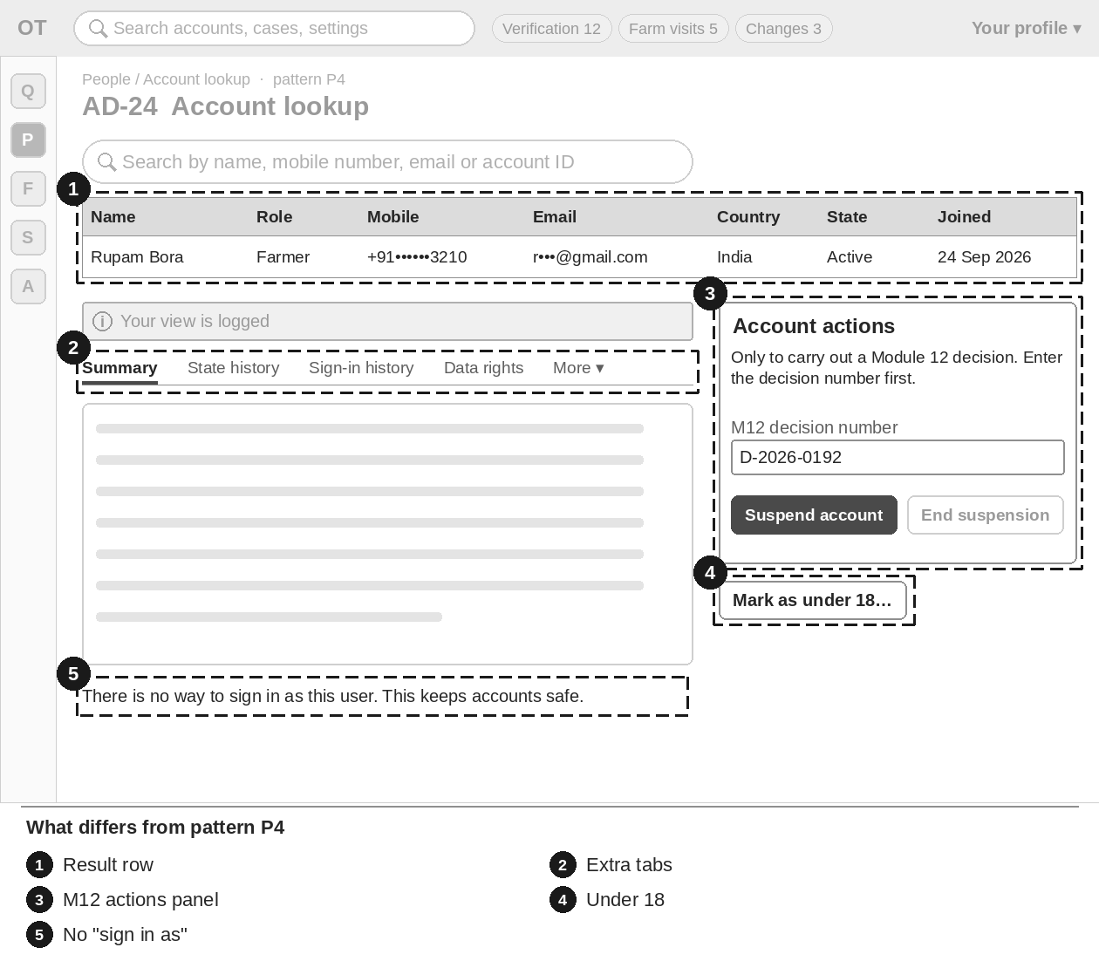
Figure 30 — AD-24 Account lookup — numbered boxes show what differs from P4
Item | Brief
What differs (numbers match the sketch) | 1 Result row: name · role · masked mobile · masked email · country · state · joined on. Up to 50 rows.  2 Tabs for Super Admin, Admin and Moderator: State history · Sign-in history · Data-rights requests · Delegations · Invitations. Support sees the summary only.  3 Account actions panel: "M12 decision number" field first; only the button that matches the decision is active (Suspend · End suspension · Reactivate).  4 Mark as under 18 (Super Admin, Admin; no M12 decision needed).  5 Foot of the page: "There is no way to sign in as this user."
Key data shown | Summary: name, role, country, state with dates, masked contacts with "confirmed", how they joined, two-step sign-in, last sign-in, devices, open items.
Main actions | Search · Open (reason first) · Suspend · End suspension · Reactivate · Mark as under 18 · Mark data request done / Refuse.
States | "No account matches "{search}"." · "More than 50 accounts match. Add more to your search."
Rules to respect | Mobile number and email must be typed in full to search. Never shown: passwords, codes, ID photos, verification documents.
Exact texts and rules | Follow M02-6 §20.1; reason dialog §14; errors §19.10. Do not copy texts from this brief into designs; use the spec wording.

AD-25 Support profile and case view
Item | Brief
Purpose | The read-only view Support uses to answer onboarding help tickets. Moderators, Admin and Super Admin can open it too.
Who uses it | Support (read-only). Moderators, Admin and Super Admin can open it.
Pattern | P4 Look-up (Section 4.4) · menu: People › Support view · priority P2

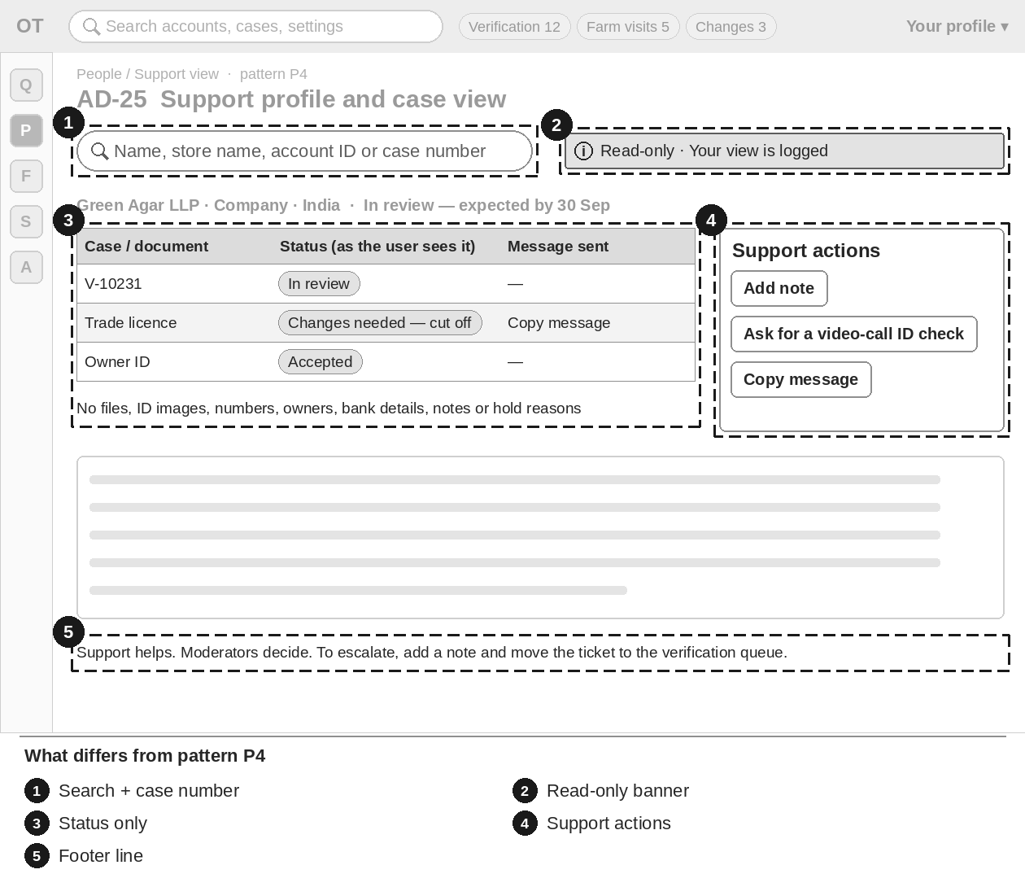
Figure 31 — AD-25 Support profile and case view — numbered boxes show what differs from P4
Item | Brief
What differs (numbers match the sketch) | 1 Search also by store name and case number; reason dialog "Why are you opening this profile?" (at least 10 characters).  2 Banner on every page: "Read-only · Your view is logged".  3 Cases with the exact message the user was sent; documents by type with status only; on-hold cases show only "In review".  4 Support actions: Add note · Ask for a video-call ID check (AD-02) · Copy message.  5 Footer: "Support helps. Moderators decide. To escalate, add a note and move the ticket to the verification queue."
Key data shown | Profile summary, verification chip with date, open setup items, cases, documents status, role request, badges, applications, video-call requests, help tickets, chip "On legal hold".
Main actions | Add note · Ask for a video-call ID check · Copy message.
States | Reason required. Not permitted. Plus the common states.
Rules to respect | Never shown: document files, ID images, selfies, scores, ID numbers (even masked), owners, bank details, map pins, internal notes, hold reasons. Decision buttons are left out, not disabled.
Exact texts and rules | Follow M03-6 §16.21; errors M02-6 §19.10. Do not copy texts from this brief into designs; use the spec wording.

7. Key Journeys
These flows show how the screens connect. Dark boxes are the main decision or result.

7.1 J1 Business verification case
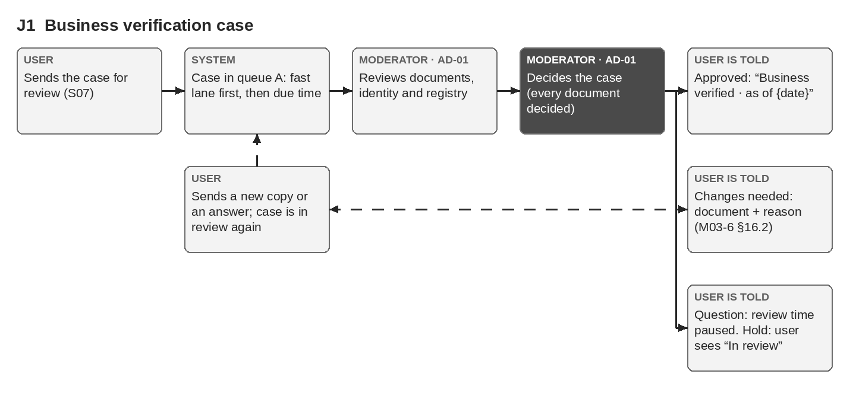
Figure 32 — J1 Business verification case

7.2 J2 FPO onboarding and member farmers
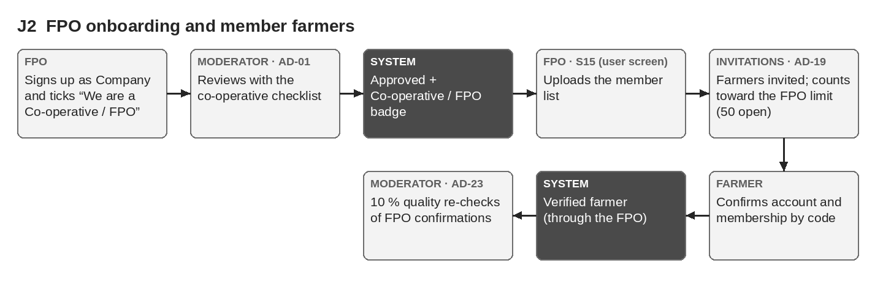
Figure 33 — J2 FPO onboarding and member farmers
S15 is the FPO’s own user screen (M03-6 §14.3); staff see FPO invitations and limits on AD-19 and FPO re-checks on AD-23.

7.3 J3 Field-agent farmer onboarding
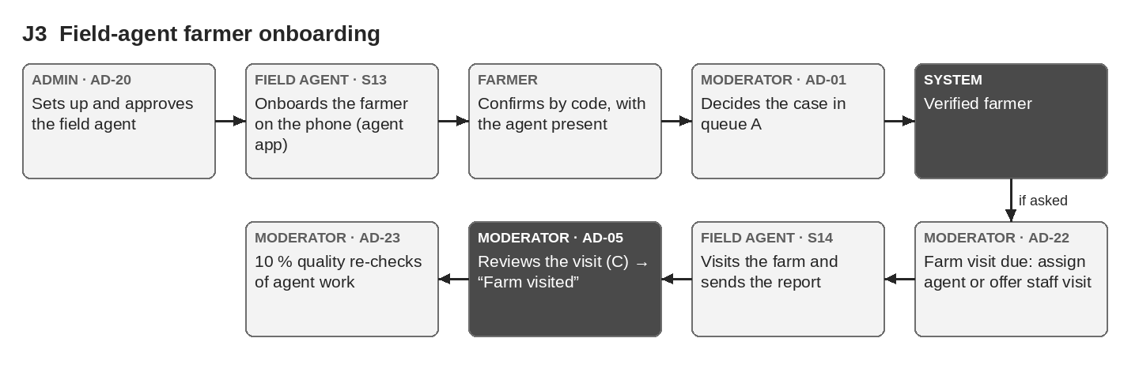
Figure 34 — J3 Field-agent farmer onboarding

7.4 J4 Buyer asks to sell
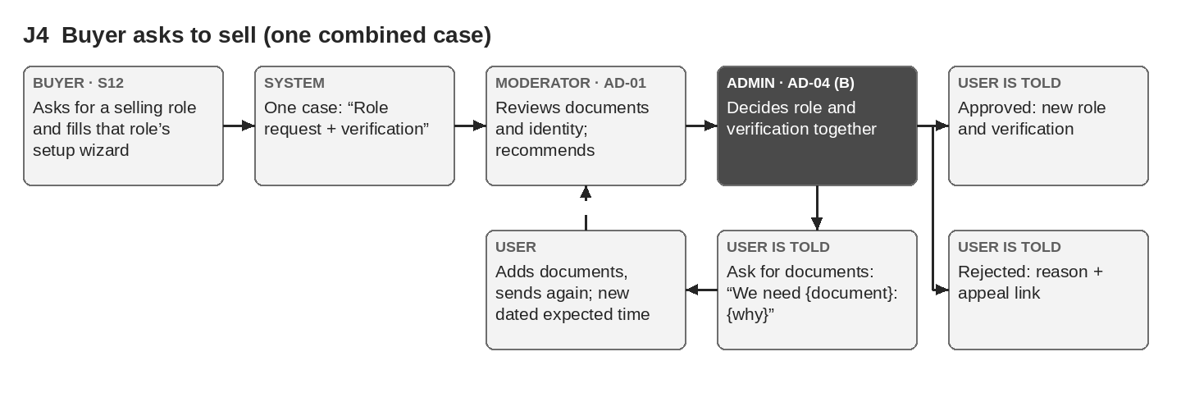
Figure 35 — J4 Buyer asks to sell — one combined case

7.5 J5 Settings change
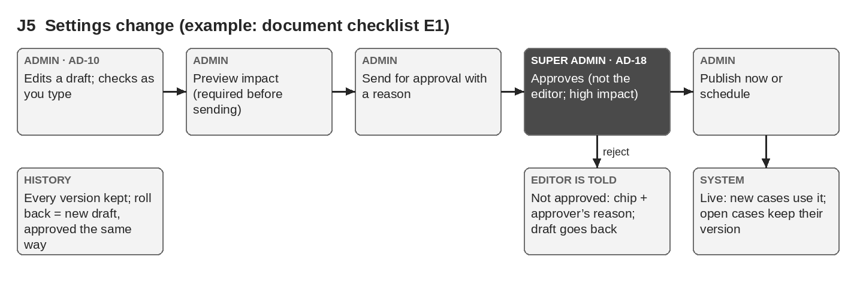
Figure 36 — J5 Settings change

8. Figma Handoff

8.1 Pages and frames
- Pages: "Admin / Shell", "Admin / P1 Queue", "Admin / P2 Settings editor", "Admin / P3 List", "Admin / P4 Look-up", "Admin / States", then one page per screen: "Admin / AD-01 Verification review" … "Admin / AD-25 Support view".
- Frames: desktop 1440 px wide (content scrolls); check each at 1280 px. Name frames "{screen ID} / {state}", for example "AD-01 / Enhanced check" or "AD-19 / Empty".
- No phone frames for the console. The field agent app (S13, S14) is a separate design.
- Put the Figma link of each page in the tracker (Screens sheet).

8.2 Reuse from the Design System
Use the starter library "OudhTrade — Design System (starter)" and its tokens: Button, Text field, Status chip, Trust badge, plus tables, tabs, dialogs and toasts from UX-UI Foundation §7.
Status chip must support the 8 verification states of M03-6 §8.2: Not started · In review · Verified · Changes needed · In review again · Expired · On hold · Verification removed. Users (and Support on AD-25) see on hold as "In review"; other staff screens show "On hold".

8.3 New components
Component | Used by | What it does
Queue table row | AD-01–AD-09, AD-22, AD-23 | Compact row with flags, fast-lane mark, due-time countdown and status chip
Due-time countdown | AD-01–AD-09, AD-19, AD-22 | "Due in {h} h" / "Overdue" with icon and words; turns red at 80 % of the target
Document viewer | AD-01, AD-02, AD-04–AD-08 | Watermark with reviewer name, time and case number; zoom, rotate, page list; "Every view is logged"
Decision bar | AD-01–AD-09 | Sticky bar at the bottom of a case; buttons change per screen
Reason dialog | All screens | Reason list and/or text (at least 10 characters); names the action and who is told
Approval bar | AD-10–AD-18 | Status chip, "High impact" chip, Send for approval / Approve / Reject / Publish / Schedule
Diff / preview panel | AD-10–AD-18 | Old → new values marked "Added", "Changed", "Retired" with icon and word; counts; example
Version history list | AD-10–AD-18 | Version, status, editor, approver, date, reason; Compare; Roll back to this version
Masked value with Show | AD-06, AD-19, AD-21, AD-24 | Masked phone or email; Show (where allowed) asks a reason, shows 60 s, is logged
Checklist ticks | AD-02, AD-05, AD-06, AD-08 | Required ticks that unlock the decision button
Photo location panel | AD-01, AD-05 | Reason first; small map, coordinates, distance; "This view is recorded with your reason."
Read-only banner | AD-24, AD-25 | "Read-only · Your view is logged" / "Your view is logged"

9. Open Questions
# | Question | Owner | Answer
1 | Dark mode for staff screens? The UX-UI Foundation (U8) says no dark mode in V1; confirm this also applies to the admin console. | Product owner | Decided 26 Sep: light mode only for the console.
2 | Table density: compact rows by default with a "comfortable" switch, or compact only? | Designer + product owner | Decided 26 Sep: compact tables by default (no switch).
3 | Can one farmer be a member of several FPOs at the same time? (open product question; affects S15, AD-19 and AD-23) | Product owner | Decided 26 Sep: yes, several FPOs allowed; each link is confirmed separately; any one confirmed link gives Verified farmer.
4 | Final list of keyboard shortcuts for queues (proposal in Section 3.3). | Designer + tech lead | Open
5 | Video-call ID check: is the video shown inside the case view or in the supplier’s own window next to it? (supplier not chosen yet) | Product owner + tech lead | Open
6 | Staff-awarded badge applications: the brief listed "Admin" as the user, but M03-6 §16.6 says a Moderator decides them on screen A. This brief follows M03-6. Confirm. | Product owner | Decided 26 Sep: a Moderator decides (AD-01 Badge applications tab); Admin only creates badge types (AD-15).
7 | Settings editors are built in the Configuration Console (M16) and staff screens in the Operations Console (M15). This brief assumes one shared shell look with the Settings menu group. Confirm. | Product owner + designer | Decided 26 Sep: one shared console shell; Settings is a menu group.
8 | Should each Moderator have a personal queue ("Assigned to me") and can cases be assigned, or does everyone pick from one shared queue? | Product owner | Decided 26 Sep: one shared queue (fast lane first, then due time); a Moderator can pick a case ("Assigned to me"); a Senior Moderator can assign cases to others.

